Buehler celebrates 100 years of Wilson® Hardness
Legacy of Reicherter, Wilson and Wolpert in present-day hardness testing systems
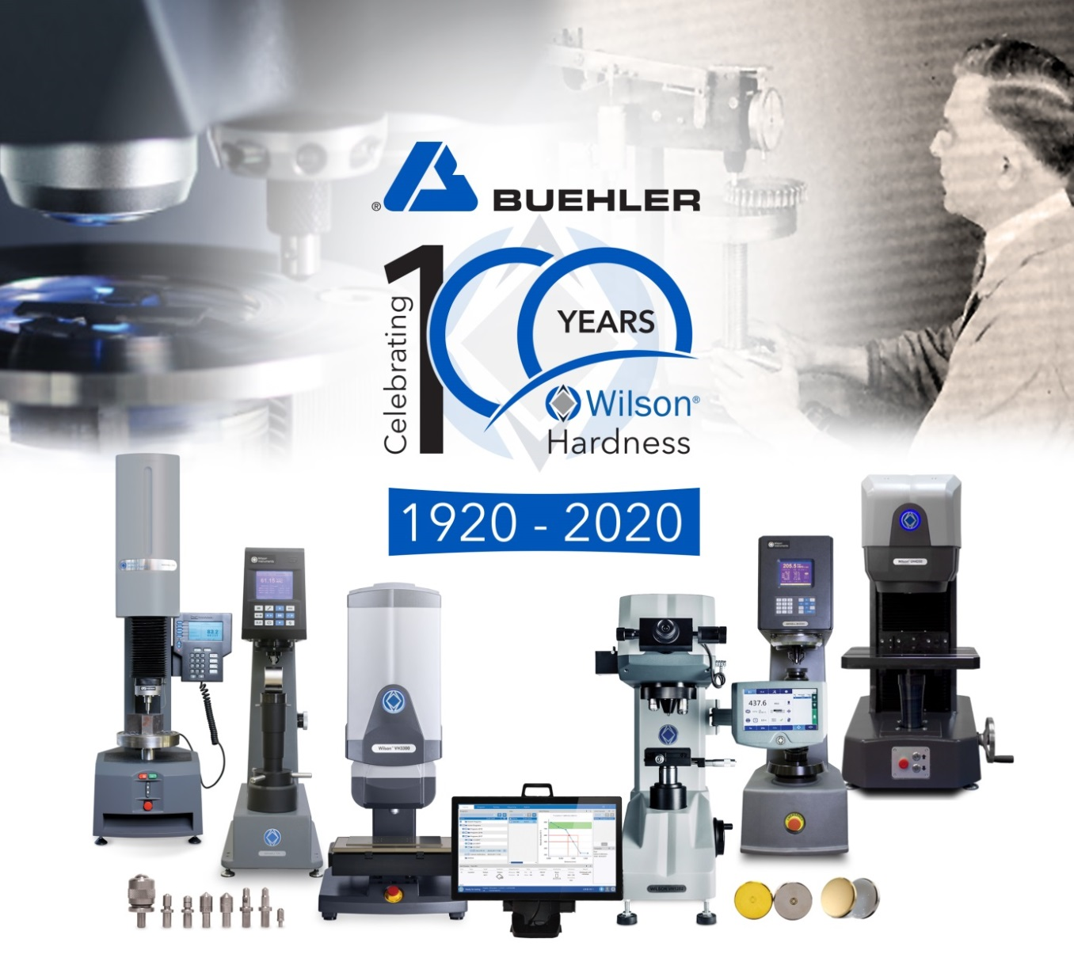
In the field of hardness testing, the product range of Buehler ITW Test & Measurement GmbH now includes devices for testing to Vickers/Knoop, Rockwell and Brinell, including the respective test blocks and automation software. © ITW Test & Measurement GmbH
Esslingen/Germany, February 2020 – Buehler, an ITW company, is celebrating the 100th anniversary of its brand Wilson® Hardness. In 1920, Stanley Rockwell and Charles H. Wilson, the founder of Wilson Mechanical Instrument Company, presented the Rockwell hardness tester, which subsequently became the industry standard. This was later followed by the legendary Tukon micro-hardness testers for Knoop and Vickers testing. These early inventions paved the way for the developments that are today reflected in the extensive portfolio of Buehler hardness testers and are famed for their user friendliness, full connectivity and high level of automation.
The Wilson® brand, which encompasses the Reicherter, Wilson and Wolpert hardness testers, has, since 2012, been part of Buehler's product portfolio. Julien Noel, General Manager of Buehler, says: "We are proud of our 100-year legacy of Wilson hardness testing. Our products are nowadays the preferred choice for demanding labs that need to meet consistently high quality standards – in research and education as well as under tough everyday conditions found in industry shop floors. Continuing this long tradition, we will this year launch a new and improved Rockwell tester and further speed up the dispatch of hardness testing systems and hardness reference test blocks."
Buehler's portfolio in the field of hardness testing currently comprises Rockwell (R574 and R2000), Knoop/Vickers (VH1000 and VH3000 series), Brinell (BH3000) and Universal hardness testing (UH4000 series) systems. These machines are found in various sectors of the economy ranging from research and development to high volume production and quality control environments. The relevant DiaMet software offers controlling, data management and reporting options and is suitable for manual to fully automatic production systems. ISO, ASTM and JIS-certified test blocks, accessories and equipment round off the range.
Buehler – ITW Test & Measurement GmbH, Esslingen/Germany has been a leading manufacturer of instruments, consumables and accessories for metallography and materials analysis since 1936, and also supplies a comprehensive range of hardness testers and hardness testing systems. A dense network of branch offices and dealers means our customers can depend on professional assistance and service around the world. The Buehler Solutions Centre in Esslingen and further centers of this kind in Europe and elsewhere can offer all kinds of assistance with application questions or with devising reproducible preparation procedures.
Buehler is part of the Test and Measurement Segment of the US company Illinois Tool Works (ITW) with some 100 decentralized business units in 52 countries and around 51,000 employees
For further information about products and services available from Buehler ITW Test & Measurement please visit https://www.buehler.com
Editorial contact and voucher copies:
Dr.-Ing. Jörg Wolters, Konsens PR GmbH & Co. KG,
Im Kühlen Grund 10, D-64823 Groß-Umstadt – www.konsens.de
Phone: +49 (0) 60 78 / 93 63 - 0, Fax: - 20, E-Mail: mail@konsens.de
Dear colleagues, Press releases from Buehler including text and pictures in printable resolution can be downloaded from www.konsens.de/buehler.html

