For routine tasks in materialography:
User-friendly EcoMet 30 grinder-polishers save time in sample preparation
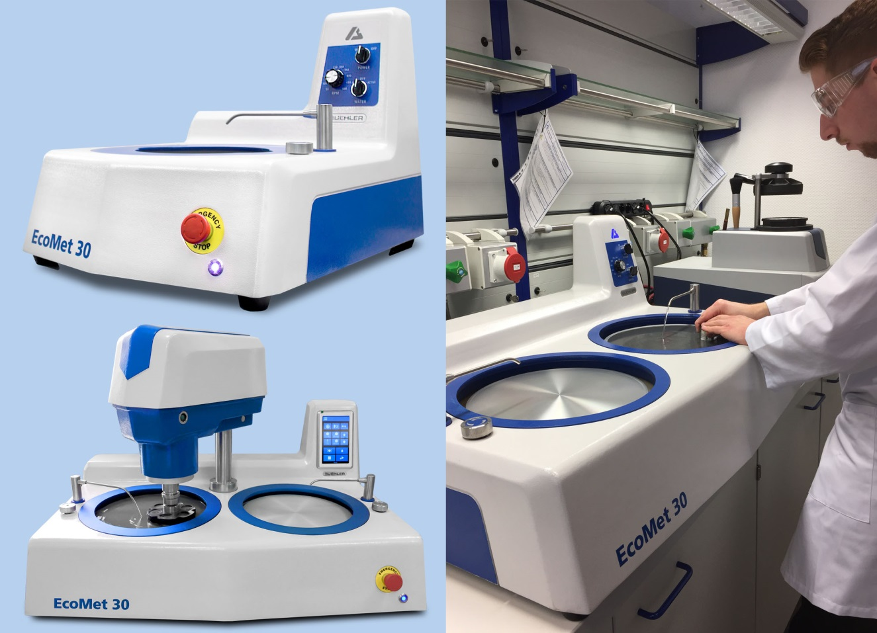
The EcoMet 30 family of grinder-polishers from Buehler includes manual or semiautomatic, single or twin versions. These machines reduce labor and enhance productivity for routine sample preparation tasks – without compromising the consistency and quality of results.
© ITW Test & Measurement GmbH
Esslingen/Germany, November 2017 – Buehler, an internationally leading manufacturer of high-performance consumables and equipment for materials testing has extended its portfolio in the area of grinding and polishing with its new EcoMet 30 system, which is designed for maximum ease of operation. The machines in this family of grinder-polishers are available in both manual and semiautomatic versions, and equipped with either one or two platens. The four models provide varying, but in all cases significant, degrees of reduction in operator workload and a corresponding increase in productivity, particularly for routine tasks in test laboratories using a dedicated machine for each preparation stage.
The semi-automatic grinder/polisher machines EcoMet 30 Auto and Auto Twin, in particular, facilitate and speed up work in the test laboratory. Frequently used functions are accessible on the front-side touch-screen user interface with 7“-LCD color screen. All settings can be made here without having to navigate through complex menus. In addition, advanced cleaning functions available in all models contribute towards significant time savings.
Both the manual and the semi-automatic models provide platen diameters of 8” [203 mm], 10” [254 mm], and 12” [305 mm], with incremental adjustment of speed within a range of 50 to 500 rpm. In the case of the manual systems, the convenient design of the splash guard, combined with a large work space and ergonomic bowl height, allows for excellent control of the grinding and polishing process while holding a material sample. In the case of the semiautomatic models, this function is provided by the machine head, which is equipped with a separate drive unit. Loaded with up to four round samples with diameters of 25, 30 or 40 mm, its contra-rotating sample holder rotates at a speed of 30 to 200 rpm.

Matthias Pascher, Product Manager Hardness & Image Analysis at Buehler said: "The name EcoMet 30 stands for maximum dependability and time savings in grinding and polishing processes. In the Auto versions, for example, the sample holder is extremely easy to install and remove. Combined with the swing-out head, this saves a lot of time when handling the samples between the different preparation steps. All models allow easy removal of the platen, which is very useful for deep-cleaning to avoid cross-contamination, as is the straight drain system. With these user-friendly features, and above all, with the optional intuitive touch-screen user interface, the systems from the EcoMet 30 family make a valuable contribution towards increasing sample throughput and thus enhancing productivity in a test laboratory."

Buehler – ITW Test & Measurement GmbH, Esslingen/Germany, has for 80 years been a leading manufacturer of instruments, consumables and accessories for materialography and materials analysis and also supplies a comprehensive range of hardness testers and hardness testing systems. A tight network of branch offices and dealers means our customers can depend on professional assistance and service around the world. The Buehler Solutions Center in Esslingen and further centers of this kind in Europe and elsewhere can offer all kinds of assistance with application questions or with devising reproducible preparation procedures.
Buehler is part of the Test and Measurement Segment of the US company Illinois Tool Works (ITW) with some 200 decentralized business units in 52 countries and around 45,000 employees.

Editorial contact and voucher copies:
Dr.-Ing. Jörg Wolters, Konsens PR GmbH & Co. KG,
Hans-Kudlich-Straße 25, D-64823 Groß-Umstadt – www.konsens.de
Tel.: +49 (0) 60 78 / 93 63 - 0, Fax: - 20, Email: mail@konsens.de
Dear colleagues, Press releases from Buehler including text and pictures in printable resolution can be downloaded from: www.konsens.de/buehler.html: www.konsens.de/buehler.html

