Chemours to showcase advances in
Teflon™ coatings for Industrial Bakery Solutions systems at iba 2015
iba – Hall A1 Booth 327– MUNICH 12. – 17. SEP 2015

Neu-Isenburg/Germany, August 2015., The Chemours Company (“Chemours”) (NYSE: CC), a global chemical company with leading market positions in fluoroproducts, titanium technologies and chemical solutions will be presenting the latest developments to its Teflon™ coatings for Industrial Bakery Solutions at this year’s iba trade show (Hall A1 Booth 327) in Munich.

Teflon™ coatings for Industrial Bakery Solutions raise the benchmark in the professional baking industry, thanks to a class-leading range of products and treatments that have been developed to ensure that bakery professionals have access to outstanding non-stick bakery solutions. Users can enhance efficiency and improve the hygiene of their operations, while simultaneously improving the quality and nutritional benefit of their products.

Other immediate benefits include longer baking equipment service life, higher throughput and the elimination of secondary release agents. The absence of oils and greases promotes improved product appearance and quality, while lowering maintenance and cleaning costs. This approach is supported by the market as comprehensive surveys of both suppliers and users have highlighted the need for equipment that is easy to clean and maintain, while reducing the number of changeovers and keeping costly downtime to an absolute minimum.

In addition to the advanced coating technology, the programme is further enhanced by strictly audited licensed applicators, who form the international partner network.

Recent successes from partner companies include Kempf GmbH, which has opened its new plant in Rohrbach, Germany with a certified Teflon™ coating production line for high-quality baking moulds and trays.In the Netherlands, Technoflon Coating Systems bv has completed a capacity extension of its plant in Doetinchem, which will enable the company to increase its production of high-quality flat and tin sets for industrial bakeries. Another strong partner company, Kaak Bakeware, is driving demand creation for Teflon™ coatings for Industrial Bakery Solutions by continuously developing and delivering the inherent benefits of a Teflon™ based approach to larger bakery plants.

The key value of Teflon™ coatings for Industrial Bakery Solutions to industrial bakeries is the availability and specification of the most appropriate and durable non-stick coating system for their production environment. Coating system considerations include: ingredients, baking processes and size and shape of the finished products.

There are eight Teflon™ coatings for Industrial Bakery Solutions, categorised into four groups:
- F-systems for flat trays or those with small indentation such as bun and croissant trays;
- D-systems for drawn tin sets such as sandwich bread;
- P-systems for perforated, flat or corrugated trays such as baguette trays;
- S-systems for special applications, such as pizza trays, pretzels, etc.

The International Partner Network
Teflon™ coatings for Industrial Bakery Solutions are exclusively available on baking equipment manufactured and marketed by a network of licensed marketers and are applied by a separate network of licensed applicators.

To learn more about Teflon™ coatings for Industrial Bakery Solutions, go to: https://www.chemours.com/Industrial_Bakery_Solutions/en_GB/index.html

About The Chemours Company
The Chemours Company helps create a colorful, capable and cleaner world through the power of chemistry. Chemours is a global leader in titanium technologies, fluoroproducts and chemical solutions, providing its customers with solutions in a wide range of industries with market-defining products, application expertise, and chemistry-based innovations. Chemours ingredients are found in plastics and coatings, refrigeration and air conditioning, mining and oil refining operations and general industrial manufacturing. Our flagship products include prominent brands such as Teflon™, Ti-Pure™, Krytox™ Viton™, Opteon™ and Nafion™. Chemours has approximately 9,000 employees across 37 manufacturing sites serving more than 5,000 customers in North America, Latin America, Asia-Pacific and Europe. Chemours is headquartered in Wilmington, Delaware and is listed on the NYSE under the symbol CC. For more information, please visit chemours.com or follow Chemours on Twitter at @chemours.

# # #

Chemours™ and the Chemours Logo are trademarks or registered trademarks of The Chemours Company.

CONTACT:
Chemours Deutschland GmbH
Horst Ulrich Reimer
Frankfurter Str. 229
D-63236 Neu-Isenburg
Phone: +49 (0)6102 / 82233-1297
E-mail: Horst-Ulrich.Reimer@chemours.com

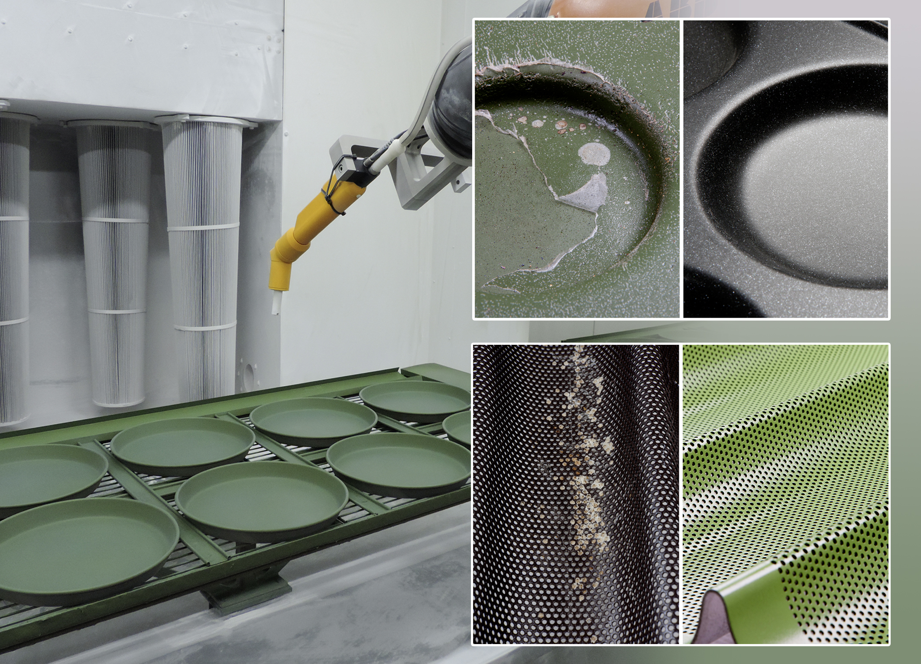

Teflon™ coatings for Industrial Bakery Solutions ensure that the application of baking surfaces and their subsequent finish and performance are optimised to specific baking applications and prevent early and costly delaminating of trays and sheets (see inserted images left).
Photo: Chemours/Kempf GmbH

