Triaxial cables made with Teflon™ fluoroplastics from Chemours
enable very high measuring accuracy in the nanometer range

Geneva/Switzerland, April 2016 – The Chemours Company (“Chemours”) (NYSE: CC), a global chemistry company with leading market positions in titanium technologies, fluoroproducts and chemical solutions, announces that HEW-KABEL, Wipperfürth/Germany (www.hew-kabel.com) uses Teflon™ fluoroplastics from Chemours for triaxial cables used in high-precision measuring devices.
Capacitive sensors from Micro-Epsilon, Ortenburg/Germany (www.micro-epsilon.de), are designed for contactless path, distance and position measurements, and ensure outstanding accuracy and stability. So that the measurements are not impaired by outside influences, use is made of special triaxial cables from HEW-KABEL. Thanks to their structure and the combination of two Teflon™ fluoroplastic types from Chemours, these cables have very good electrical properties such as extremely low noise voltage. They thus contribute to the high measuring accuracy of up to 0.2 nm – a figure that corresponds approximately to the diameter of a cesium atom. Typical fields of application include the automation industry, in particular semi-conductor technology and photolithography.
A special characteristic of these cables is the banding. HEW-KABEL has developed its own highly conductive PTFE film for this because conventional films available on the market did not have the necessary quality in combination with high conductivity. The base material used is Teflon™ 669N X from Chemours. The main reasons for choosing this material were its good compounding and processing properties. The material also has good mechanical properties even with high contents of conductive additives, and can be stripped mechanically.
For the insulation and sheathings, HEW-KABEL uses Teflon™ FEP 100 X fluoroplastic from Chemours, a melt-extrudable copolymer of tetrafluoroethylene and hexafluoropropylene. The material is free of additives, has very high chemical resistance and temperature stability, good electrical properties and relatively low permittivity. It also has low outgassing, which is particularly important for applications in a vacuum or clean room. Thanks to the excellent processing properties of Teflon™ FEP 100 X, insulating and dielectric layers with low wall thicknesses and very small diameters can be produced.
Both of the Teflon™ grades used by HEW-KABEL also have extremely low flammability. The triaxial cables produced from them are classified to UL 444 in the highest fire protection category of CMP (CMP = communication plenum). They are noted for their very high flame retardancy and low fume/smoke development.
One example of an application for the capacitive sensors from Micro-Epsilon is a system for measuring the thickness of silicon wafers for the production of photovoltaic cells or semi-conductors. The wafers are measured for their wedgeness and flatness. After sawing, the wafers are subjected to a complex machining stage to attain optimum planarity. With semi-conductor wafers with a thickness of e.g. 900 µm, the flatness must be in the range of below 5 nm. During the course of the various processing steps from lapping and etching through to polishing, the wafers have to be examined several times.
Further information on Teflon™ fluoroplastics from Chemours for cable applications can be found on the Internet at www.chemours.com/Cabling_Solutions/en_US/products/index.html
About HEW- KABEL
HEW-KABEL is a medium-sized company in Wipperfürth, 50 km east of Cologne. We employ more than 300 people in research and development, and production and sales. Their qualifications are always kept up to date through continuous training. From technical design to production to sales, we offer everything from one source. Using its many years of know-how and experience, HEW-KABEL designs, develops and manufactures customer-specific cable solutions for various industrial market segments, where miniaturization, flexibility or special durability are required. Fields of application include the automotive industry, the aerospace industry, medical equipment, robotics, instrumentation and control technology, sensor technology, traffic technology, high frequency technology as well as mechanical engineering.
About The Chemours Company
The Chemours Company (NYSE: CC) helps create a colorful, capable and cleaner world through the power of chemistry. Chemours is a global leader in titanium technologies, fluoroproducts and chemical solutions, providing its customers with solutions in a wide range of industries with market-defining products, application expertise and chemistry-based innovations. Chemours ingredients are found in plastics and coatings, refrigeration and air conditioning, mining and oil refining operations and general industrial manufacturing. Our flagship products include prominent brands such as Teflon™, Ti-Pure™, Krytox™, Viton™, Opteon™ and Nafion™. Chemours has approximately 8,100 employees across 35 manufacturing sites serving more than 5,000 customers in North America, Latin America, Asia-Pacific and Europe. Chemours is headquartered in Wilmington, Delaware and is listed on the NYSE under the symbol CC. For more information, please visit chemours.com or follow Chemours on Twitter at @chemours.

# # #
Chemours™ and the Chemours Logo are trademarks or registered trademarks of The Chemours Company.
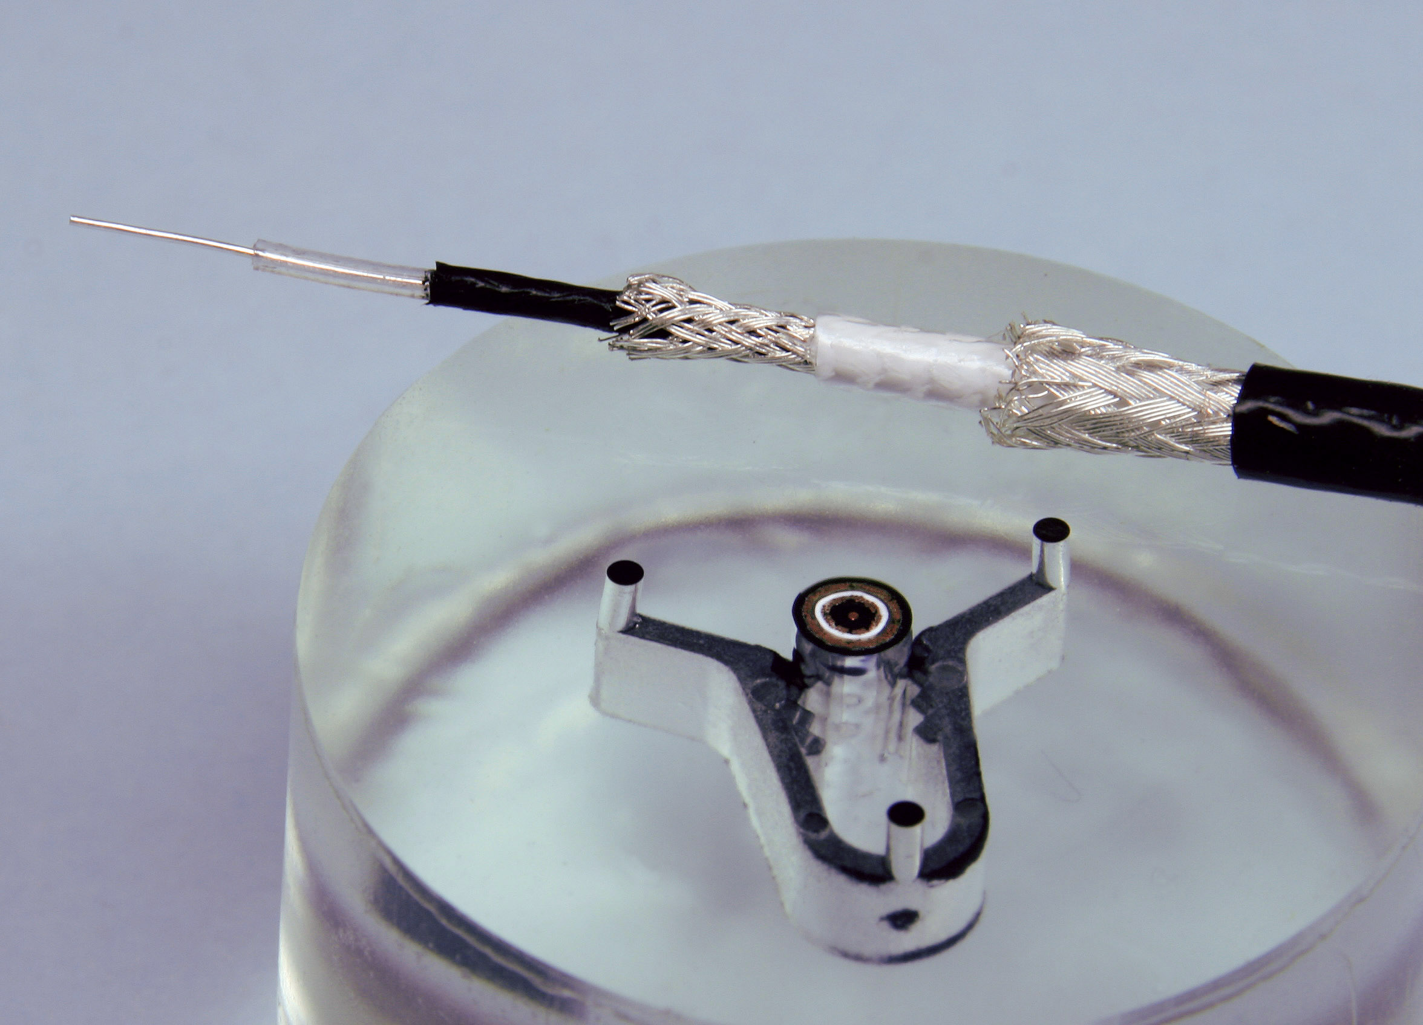
Picture: Chemours
In order to ensure the high measuring accuracy of contactless path, distance and position measurements with the help of capacitive sensors, Micro-Epsilon uses triaxial cables manufactured by HEW-KABEL. They combine two Teflon™ fluoroplastic types from Chemours.

CONTACT:
Chemours International Operations Sarl
Chemin du Pavillon 2
CH-1218 Le Grand Saconnex, Geneva
Lene Stosic
Phone: +41 22 719 1622
E-mail: Lene.Stosic@chemours.com

