DuPont Protection Solutions at the A+A trade fair:
expanded protective clothing portfolio for still more safety and comfort
Tyvek® 500 HV high visibility coverall, updated Tychem® portfolio
and new Tyvek® IsoClean® clean room range – 50 years of Tyvek®, Nomex® and Kevlar®
Düsseldorf/Germany, 17 October 2017. At this year's A+A trade fair, DuPont (hall 5, stand A40) is presenting its extensive portfolio of protective clothing that protects against chemicals, biohazards, heat and fire as well as against cuts and impacts. The focus is the broad market launch of Tyvek® 500 HV, a high visibility type 5-B/6-B chemical coverall, as well as of Tychem® 6000 F FaceSeal, a type 3-B, 4-B, 5-B and 6-B chemical coverall with very high tightness. The new Tyvek® IsoClean® clean room range is another highlight of the trade fair stand. DuPont is also showing new solutions with Nomex® safety clothing that protects against heat, fire and electric arcing for firefighters and industrial workers as well as protective garments made from Kevlar® aramid fibre. Moreover, the company is also celebrating the 50th anniversary of its Tyvek®, Nomex® and Kevlar® brands.
Chemical protection and high visibility
The new Tyvek® 500 HV combines protection against chemicals, biohazards and solid airborne particles with high visibility. It is made with Tyvek® material of fluorescent orange colour with silver grey reflective bands, so ensuring compliance with EN ISO 20471:2013 for high visibility clothing in the highest visibility class 3. As a limited-use coverall, this suit is immediately sent for appropriate disposal after contamination or heavy soiling. In contrast, reusable high visibility clothing is costly to wash and maintain in such a way that it still meets the requirements of the standard even after washing. With Tyvek® 500 HV, workers get a new protective garment instead, whose fluorescent and reflective properties are still fully intact. Typical fields of application are activities in dangerous environments with poor visibility and weather conditions, for example the railway sector, mining, waste disposal and road construction.
With the help of a virtual environment, which is set up at the trade stand, visitors can experience a full 360-degree all-round view of the advantages of the Tyvek® 500 HV.
Updated Tychem® portfolio
Just recently DuPont has updated its range of Tychem® type 3-B, 4-B, 5-B and 6-B chemical protection coveralls and expanded it with four new models Tychem® 6000 F FaceSeal, Tychem® 6000 F, Tychem® F with dissipative socks and Tychem® 4000 S. Thanks to their innovative design features, they provide not only better protection but also greater comfort and freedom of movement.
Tychem® 6000 F FaceSeal is the flagship of this line of products. It has a wide rubber seal ('FaceSeal') around the hood, which fits closely against a full-face mask, ensuring a very high level of tightness which cannot be achieved with conventional taping. This model is easy to put on and take off thanks to its rear entry. In addition, the front is free of openings through which hazardous substances could enter the garment. Other safety-enhancing features include the chemical-resistant undergloves and integrated socks with knee-high boot covers.
Comprehensive protective clothing range for controlled environments
The Tyvek® IsoClean® line of products, designed especially for use in clean rooms, is new to the DuPont product range. It includes CE-certified coveralls, labcoats, sleeves, boot covers, hoods and masks. All Tyvek® IsoClean® products are produced, packaged and certified according to European and international standards. They offer an advantageous combination of protection, quality, comfort and contamination control. They are available in three variants:
- clean-processed and sterile – sterilized with gamma rays (SAL 10⁻⁶), specially processed to ensure a minimum particle release and packaged in an ISO Class 4 clean room
- sterile – sterilized with gamma rays (SAL 10⁻⁶)
- bulk packed and non-sterile
50 years of Tyvek®, Nomex® and Kevlar®
At this A+A trade fair, the company also celebrates the 50th anniversary of its Tyvek®, Nomex® and Kevlar® brands. Tyvek® consists of very finely woven fibres of high density polyethylene (PE-HD) that are subjected to heat and pressure to form a nonwoven material. This results in a material that is light, permeable to air and water vapour, yet simultaneously robust. It has a high tear and abrasion resistance as well as providing an inherent barrier against dust, pulverulent hazardous substances and numerous water-soluble chemicals. Every day, coveralls made from Tyvek® protect millions of people worldwide.
Nomex® is an inherently heat and flame resistant fibre. Fabrics made from this material provide the wearer with protection against heat and flames, the effects of electric arcing as well as liquid metal splashes. Today, more than three million firefighters rely on turnout gear and station wear as well as accessories made out of Nomex® brand fibres. Clothing made from Nomex® is also worn by military pilots and combat vehicle crews, racing drivers and pit crews, as well as industrial workers.
Kevlar® aramid fibres are approximately five times stronger than steel, very light in weight, as well as acid and heat resistant. As an essential element of bullet-proof vests and helmets, they make a day to day contribution to saving the lives of policemen and soldiers. In addition, these fibres are used in numerous other products such as protective clothing, aircraft parts, tyres and cables.
More information on ipp.dupont.com or safespec.dupont.co.uk.
About DowDuPont
DowDuPont (NYSE: DWDP) is a holding company comprised of The Dow Chemical Company and DuPont with the intent to form strong, independent, publicly traded companies in agriculture, materials science and specialty products sectors that will lead their respective industries through productive, science-based innovation to meet the needs of customers and help solve global challenges. For more information, please visit us at www.dow-dupont.com.

About DowDuPont Specialty Products Division
DowDuPont Specialty Products, a division of DowDuPont (NYSE: DWDP), is a global innovation leader with technology-based materials, ingredients and solutions that help transform industries and everyday life. Our employees apply diverse science and expertise to help customers advance their best ideas and deliver essential innovations in key markets including electronics, transportation, building and construction, health and wellness, food and worker safety. DowDuPont intends to separate the Specialty Products division into an independent, publicly traded company. More information can be found www.dow-dupont.com.
###
The DuPont Oval logo, DuPont™ and all products denoted with ® or ™ are registered trademarks or trademarks of E.I. du Pont de Nemours and Company or its affiliates.
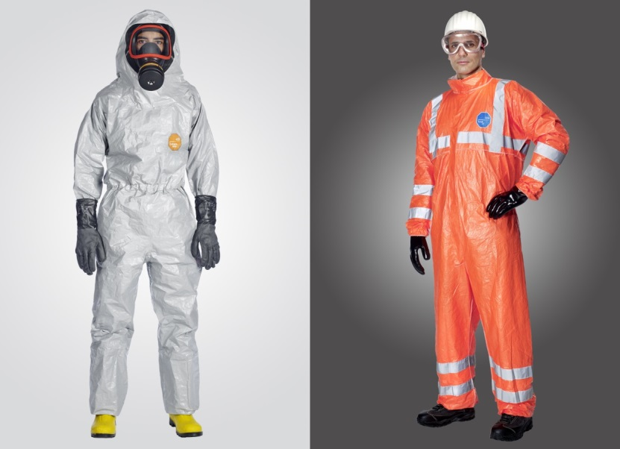
Photo: DuPont
Tychem® 6000 F FaceSeal (on the left) and Tyvek® 500 HV (on the right) are the highlights of DuPont's presence at the A+A trade fair.
The use of the material provided here by DuPont (photos, slides, files, etc.) is allowed exclusively for journalistic purposes in connection with the texts provided by DuPont for the same purpose. Its use to illustrate products and/or services of companies other than DuPont is strictly prohibited.

EN ISO 20471:2013:High Visibility Clothing – Test methods and requirements

