A long-standing SNCF partner, DuPont Protection Solutions has developed Tyvek® 500 HV, 2-in-1 coveralls that protect against biological and railway risks
Düsseldorf/Germany, 17 October 2017. Near the railway station in Limoges Bénédictins (87) can be found one of the SNCF Equipment Management's 38 maintenance Technicentres: the MTE's (Maintenance and Traction Establishment) Locomotives Depot in Limousin. On this site employing 450 staff devoted to the light maintenance of TER (Regional Express Transportation) engines, 150 employees work every day in the workshop or outdoors to maintain and repair the trains.
To ensure their safety, the SNCF wanted protective clothing that provides both a barrier to chemicals and high visibility. DuPont Protection Solutions met this challenge by developing, in close collaboration with SNCF teams, Tyvek® 500 HV coveralls.
A partnership that is working for safety
Béatrice Boussavie, the local OSH expert in charge of occupational risk prevention at the MTE in Limousin, provides each of its workers with 23 woven, washable, high visibility articles of workwear. In addition to this, they are also equipped with DuPont™ Tyvek® Dual limited use coveralls, for dirty jobs in the workshop.
To protect workers exposed to railway risks during work carried out near railway tracks that are in use, Lionel Delport from the Safety department of Equipment Management was looking for type 5 and 6 coveralls that would meet several essential criteria:
- high visibility in compliance with the EN ISO 20471 (Class 3/3) standard for the prevention of railway risks,
- a chemical barrier to many low concentration aqueous inorganic chemical products (such as diesel, coolant, oil, etc.) and to small, dangerous particles,
- protection against exposure to biological risks, especially for workers carrying out visual examinations of trains following impacts with animals or people,
- a hoodless design so as not to impede hearing because workers have to be able to hear an approaching train.
Lionel Delport therefore turned to DuPont Protection Solutions, "a dynamic company that listens to its users." The only manufacturer to get involved in this project, DuPont Protection Solutions is also the SNCF's sole supplier of limited use workwear. Following more than 12 months' close collaboration between teams from the SNCF and DuPont Protection Solutions, Tyvek® 500 HV is now being worn by the 150 maintenance workers of the MTE in Limousin.
Tyvek® 500 HV: an all-in-one solution
Offering all the characteristics of Tyvek® disposable coveralls, the new Tyvek® 500 HV coveralls designed by DuPont Protection Solutions meet every one of the SNCF's specifications.
In addition to having recognized qualities of durability and breathability as they are made of Tyvek®, they also combine chemical, biological and antistatic protection with the highest class of visibility. Thanks to their fluorescent orange color and silver-gray retro-reflective stripes, these coveralls with a mandarin collar allow SNCF workers "to be much more visible and more easily identifiable by train drivers both during the day and at night." Ideal for ensuring worker safety in dark and dangerous environments or during bad weather conditions, for Lionel Delport and Béatrice Boussavie, "Tyvek® 500 HV coveralls are both Personal Protective Equipment and Visual Signaling Equipment, protecting maintenance workers against chemical risks, dirt and the danger of being hit by traffic."
The new coveralls designed by DuPont Protection Solutions present another important advantage for Lionel Delport: "since they are designed for limited use, and will never be washed, they retain their fluorescent and retro-reflective properties until they are discarded, unlike woven apparel which, with repeated washing, cannot continue to guarantee this performance."
Robust and light, Tyvek® 500 HV remains comfortable to wear thanks to its ergonomic design and its relaxed fitting in the crotch area. As Kevin Gouron, a heating engineer at the MTE in Limousin, says "Tyvek® 500 HV coveralls are highly visible for railway risks and provide a better barrier to chemical risks, and all of this with a level of comfort identical to that of Tyvek® Dual coveralls."
Managing to reconcile optimum safety and economy
Another aim of these new coveralls designed by Lionel Delport from the SNCF was to reduce the number of articles of clothing provided to each worker, and especially those supplied to interns and student-apprentices, who were given the same number of outfits as the full-time workers. Equipping them, for dirty work in particular, with disposable high visibility coveralls represented "a real gain in costs in the long term for the company with respect to both the industrial washing of HiVi clothing and the supply of this apparel to workers, avoiding any problems with PPE not being returned after holidays."
Worn by employees over their woven work clothes, Tyvek® 500 HV illustrates "the total complementarity of these two types of PPE even though they have very different roles." Lionel Delport explains that "Tyvek® 500 HV coveralls make it possible, for example, to protect woven clothes and avoid them getting dirty, especially during work carried out by the railway maintenance workers, who regularly move between trains and are therefore exposed to particularly aggressive graphite grease."
But beyond the complementarity with woven work clothes, Lionel Delport lists many other work stations where Tyvek® 500 HV coveralls offer a real advantage: "in stand-by vehicles, for train drivers in the event of a rail accident or else for workers on their way to carry out repairs outdoors. Keeping a stock of limited-use coveralls in the emergency wagons is a safe solution, under any circumstances, for protecting workers against railway risks and dirt when they are working on the track ballast."
Illustrating the capacity for innovation of DuPont Protection Solutions and its proximity to customers, Tyvek® 500 HV proved to be entirely satisfactory for Lionel Delport and Béatrice Boussavie of the SNCF, a long-standing partner of DuPont.
More information on ipp.dupont.com or safespec.dupont.co.uk.
About DowDuPont
DowDuPont (NYSE: DWDP) is a holding company comprised of The Dow Chemical Company and DuPont with the intent to form strong, independent, publicly traded companies in agriculture, materials science and specialty products sectors that will lead their respective industries through productive, science-based innovation to meet the needs of customers and help solve global challenges. For more information, please visit us at www.dow-dupont.com.

About DowDuPont Specialty Products Division
DowDuPont Specialty Products, a division of DowDuPont (NYSE: DWDP), is a global innovation leader with technology-based materials, ingredients and solutions that help transform industries and everyday life. Our employees apply diverse science and expertise to help customers advance their best ideas and deliver essential innovations in key markets including electronics, transportation, building and construction, health and wellness, food and worker safety. DowDuPont intends to separate the Specialty Products division into an independent, publicly traded company. More information can be found www.dow-dupont.com.
XXX
The DuPont Oval Logo, DuPont™ and Tyvek® are registered trademarks or trademarks of E.I. du Pont de Nemours and Company or its affiliates.
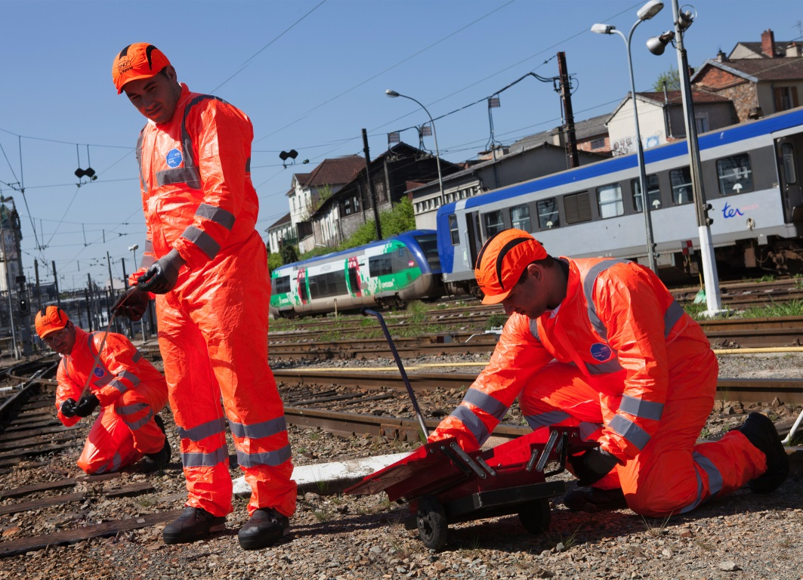
Photo: DuPont
New DuPont™ Tyvek® 500 HV combines protection against chemicals, solid hazardous substances and biological risks with high visibility. It protects employees of the French railway company SNCF during maintenance work.
The use of the images (photos, slides, transparencies, etc.) granted by DuPont is authorised only in connection with the editorial material supplied by DuPont itself and cannot be used to illustrate material related to products and/or services given by companies other than DuPont.

