DuPont is celebrating 50 years of DuPont™ Tyvek®
50 years of scientific innovation in the service of protection
Düsseldorf/Germany, 17 October 2017. Designed in 1967, DuPont™ Tyvek® is a non-woven material that has revolutionised the limited use chemical protection garment market thanks to its combination of exceptional properties: chemical barrier, durability and breathability. This unique invention has also influenced many other industries and applications for which high-performance protection was needed.
Today, with over 200 million garments and accessories sold world-wide and innovations being developed yearly, DuPont Protection Solutions has become the world's leader in chemical protection garments, especially in France, the top European market.
DuPont™ Tyvek®, a material with unrivalled performances
In 1955, Jim White, a researcher at DuPont, discovers a new source of fibres that will give rise to Tyvek®. Several years later, a Research and Development programme, led by Herbert Blades, results in the company registering a patent for high density polyethylene. Its exclusive DuPont flash spinning production process creates continuous fibres distributed randomly and in a single direction.
In April 1967, the Tyvek® brand sees the light of day. The recognised performance of the naturally white Tyvek® material resides in its unique blend of properties. Combining comfort and durability, its multi-layer structure proves to be an excellent barrier against a wide range of dry particles and liquid chemical products.
Since then, this invention has revolutionised many industries and become an invaluable material in lots of applications: paper, sterile packaging, construction materials ... and chemical protection garments.
At the end of the 1980s, DuPont, forever attentive to users' specific needs, detects a requirement for protection against the risks of exposure to liquid chemicals and therefore develops a full range of high protection Tychem® garments, designed using Tyvek® technology.
Today, thanks to their superior protection levels, several million DuPont™ Tyvek® garments are sold annually. Over the last 50 years, it has played a considerable role throughout the world, supporting emergency response efforts in many catastrophes: protection for healthcare staff in West Africa dealing with the Ebola virus, the clean-up operation following the tsunami in Japan, including the Fukushima nuclear power stations etc.
These limited use DuPont™ Tyvek® garments have set the standard for protection against hazardous dry particles, including asbestos fibres, lead dust etc. They can also be used in cleanrooms.
DuPont's expertise in the service of safety and reliability
The specialist in chemical protection garments, DuPont Protection Solutions puts the safety and quality that runs through the company's veins at the heart of its strategy. This is why DuPont Protection Solutions is committed always to exceed the standards required for PPE, as is demonstrated by the performances of the Tyvek® Classic Xpert overall, the range's flagship product.
For this type 5 and 6 garment, DuPont Protection Solutions therefore measured the permeability of the Tyvek® material with over 40 chemical products, even though the standard only requires this test from type 4. As regards garment penetration by fine particles, the standard specifies a rate of internal leakage of less than 15%. Tyvek® Classic Xpert recorded a leakage rate of just 1%, a performance well in excess of the standard's requirements!
In our continuing quest for reliability, DuPont Protection Solutions is already subjecting its overalls to some 500 chemical substances, and regularly tests them with new substances.
At the same time, DuPont Protection Solutions provides customers with access to a technical team and an interactive DuPont™ SafeSPEC™ website for advice and support in the choice of the most suitable garments for their protection requirements.
Innovation for ever better protection
For 50 years, DuPont's success has been based not only the unique properties of DuPont™ Tyvek® and its leading edge technology expertise, but also on the development of innovations. In a market that has become increasingly competitive in the last 10 years, DuPont Protection Solutions is boosting its strategy of innovations to maintain its position as the leader in chemical protection garments.
A perfect illustration of this continuing research, the Tychem® ThermoPro stands out as a unique offer on the market. The result of extremely sophisticated technical and scientific development, it offers triple protection in one single-layer garment against projections of chemical products, heat and flames and electric arcs. It also won the 2016 award for innovation at the Préventica Lille trade show.
A further example is the Tyvek® 800 J, a type 3 chemical protection garment that combines resistance to pressurised jets of aqueous chemical substances, breathability, durability and freedom of movement, thanks to its impermeable "Tyvek® Impervious Technology" technology. Designed for use in very damp environments, it offers an unequalled comfort that was recognised by the 2014 award for innovation at the Préventica Marseille trade show.
To meet customers' specific needs, DuPont Protection Solutions works closely with them to design special products, such as the Tyvek® 500 HV overall. This solution was developed in partnership with SNCF, which needed a type 5 and 6 protection garment combining high visibility, a chemical barrier, protection against exposure to biological and health risks, and a hoodless design to avoid interference with operatives' hearing.
All of these examples illustrate how DuPont has been providing its scientific and technical expertise for 50 years in the service of first-rate protection for every type of application. These 50 years of performance have built the reputation of DuPont™ Tyvek® throughout the world, and gained it the unfailing trust of all its users. A success that DuPont intends to continue in the coming 50 years as it maintains its policy of innovations to improve the way we meet market requirements.
More information on ipp.dupont.com or safespec.dupont.co.uk.
About DowDuPont
DowDuPont (NYSE: DWDP) is a holding company comprised of The Dow Chemical Company and DuPont with the intent to form strong, independent, publicly traded companies in agriculture, materials science and specialty products sectors that will lead their respective industries through productive, science-based innovation to meet the needs of customers and help solve global challenges. For more information, please visit us at www.dow-dupont.com.

About DowDuPont Specialty Products Division
DowDuPont Specialty Products, a division of DowDuPont (NYSE: DWDP), is a global innovation leader with technology-based materials, ingredients and solutions that help transform industries and everyday life. Our employees apply diverse science and expertise to help customers advance their best ideas and deliver essential innovations in key markets including electronics, transportation, building and construction, health and wellness, food and worker safety. DowDuPont intends to separate the Specialty Products division into an independent, publicly traded company. More information can be found www.dow-dupont.com.
XXX
The DuPont Oval Logo, DuPont™, Tyvek® and Tychem® are registered trademarks or trademarks of E.I. du Pont de Nemours and Company or its affiliates.
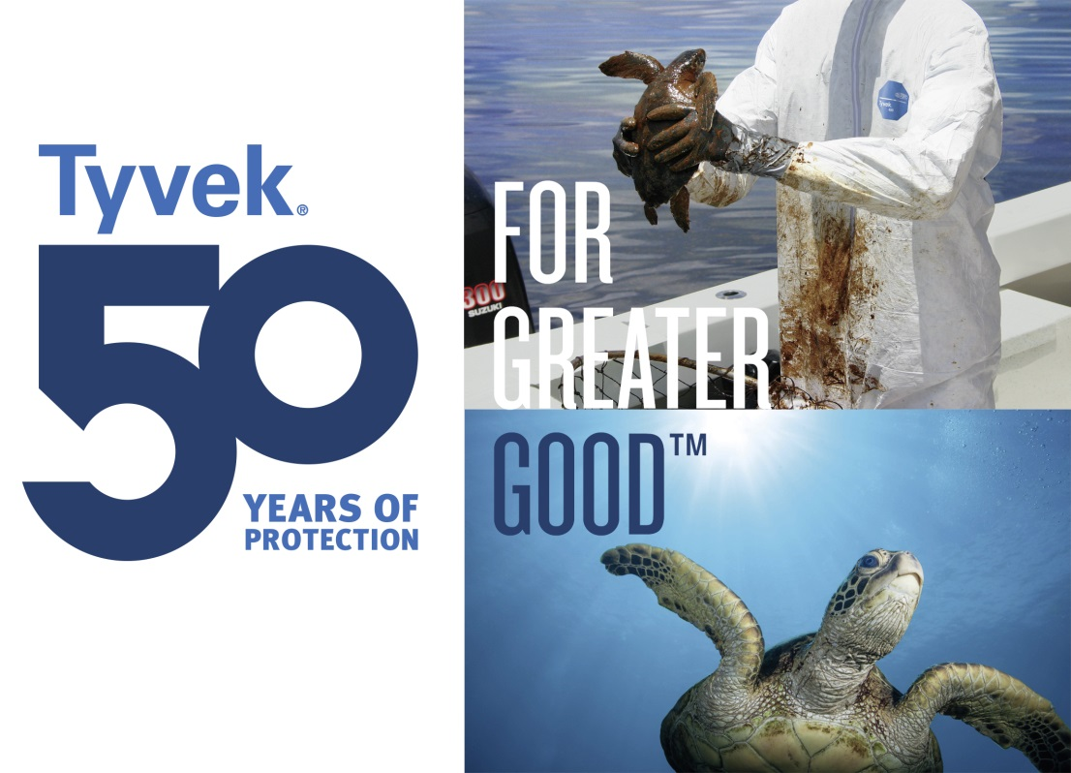
Photo: DuPont
DuPont™ Tyvek®, which has been developed 50 years ago, offers a combination of exceptional properties such as chemical barrier, durability and breathability and has revolutionised the limited use chemical protection garment market.
The use of the images (photos, slides, transparencies, etc.) granted by DuPont is authorised only in connection with the editorial material supplied by DuPont itself and cannot be used to illustrate material related to products and/or services given by companies other than DuPont.

