FOR IMMEDIATE RELEASE

Contact:
Birgit Radlinger
Marketing Communications Manager
Flow Europe GmbH
+49 (0)6151 3095-226
bradlinger@flowcorp.com

Hans Haverkort: New Business Manager Central Europe at Flow Europe GmbH
Weiterstadt, January 2018 – Effective January 1, 2018 Hans Haverkort, 52, joins Flow Europe GmbH and takes over the role as Business Manager Central Europe. In this role, he is leading the sales activities for waterjet cutting systems in the sales region Germany, Austria, Switzerland and BeNeLux. Haverkort has a comprehensive background in the waterjet cutting technology due to former assignments at Bystronic and Resato.

About Flow International
Flow International Corporation, a Shape Technologies Group company, is a leading ultrahigh-pressure manufacturing process solution provider. As the world leader in waterjet technology, the company is committed to delivering highly innovative solutions and world class customer experience to a wide customer base.

Flow Europe GmbH, a subsidiary of Flow International Corporation, with a registered office in Weiterstadt, Germany and branch offices in England, France, Italy, Spain, Czech Republic and the United Arab Emirates, provides rapid technical assistance and ensures the smooth supply of replacement parts to all customers in Europe, the Middle East and Africa. For more information, visit www.FlowWaterjet.com.

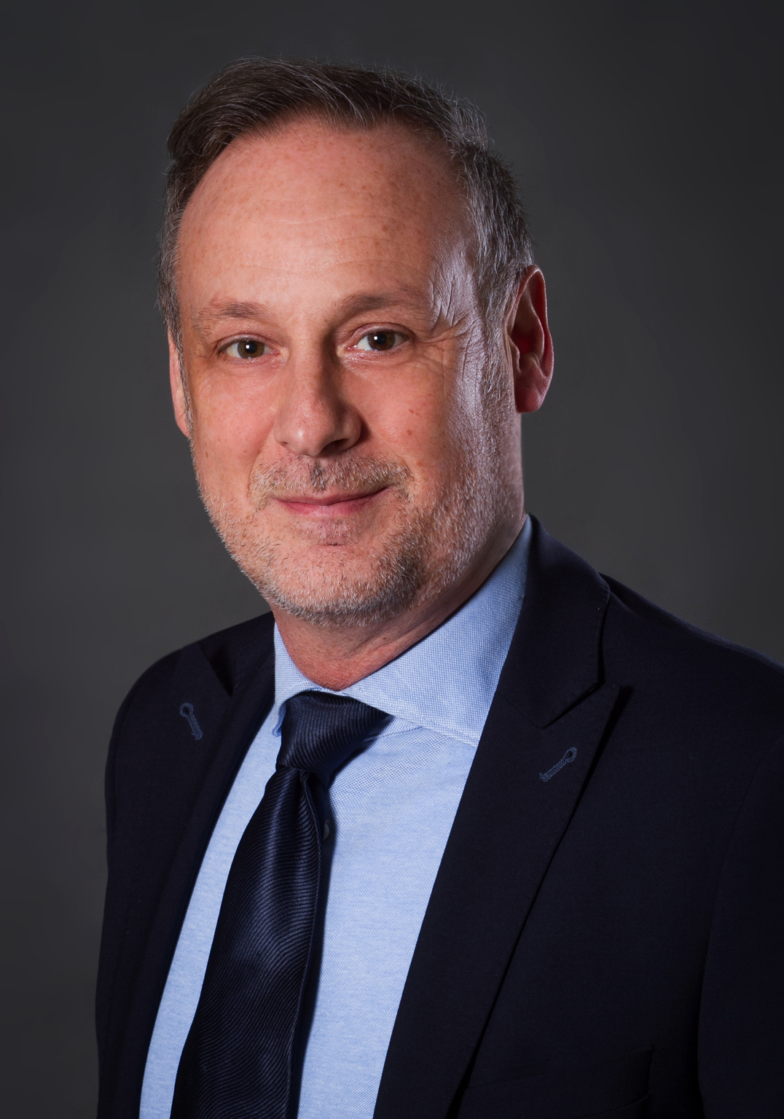
Image: Flow
Hans Haverkort, Business Manager Central Europe, Flow Europe GmbH

