Users reap the benefits of FLEXflow One – the stand-alone hot runner solution with servo-driven valve gate system
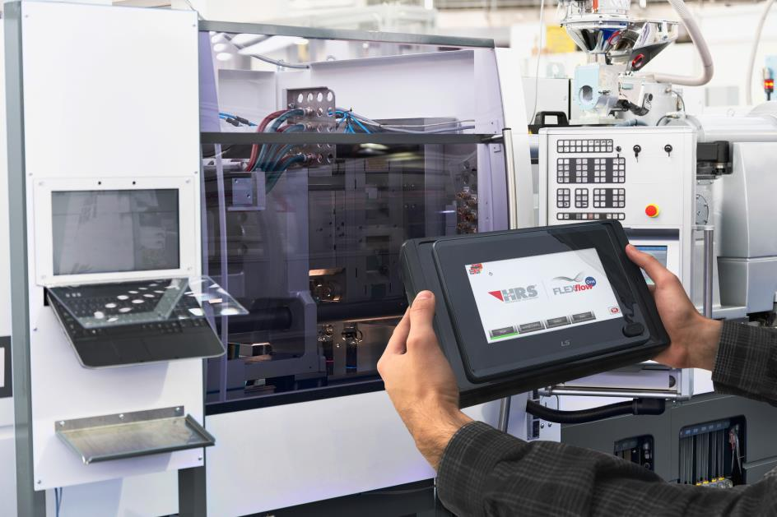
FLEXflow One, the servo-driven valve gate system for hot runner nozzles, uses an External Smart Interface (ESI) to transfer data on needle stroke, velocity and force to the integrated driver module, which then then assumes control of the needle motion. © HRSflow
San Polo di Piave/Italy, November 2017 --- One year after its launch, FLEXflow One, HRSflow’s servo-driven valve gate system for hot runner nozzles that operates as a stand-alone system avoiding the otherwise necessary control unit, already boasts a large number of applications, including the production of bumpers, front headlamps, rear lights, spoilers, door and tailgate trim. It is also being used for family molds with highly varying part weights. In all these cases, FLEXflow One delivers the desired combination of cost efficiency, unproblematic application and high-quality moldings.
With the FLEXflow One concept, instead of the usual control unit, a simple driver module connected to each individual nozzle has the task of controlling the melt flow in order to produce molded parts of high reproducible quality. The module comes with a default setting that fully opens and closes the needle. To change this setting, the operator connects up the External Smart Interface (ESI), with which he transfers data on stroke, velocity and force specifically optimized for the individual application, to the module. The module then assumes control of the needle motion, including multiple steps if required. Using ESI, up to 24 valve pins per system can be individually programmed. For extra safety compared with hydraulically driven systems, a maximum torque is set for the servo motor. This helps to prevent damage to the hot runner system and mold and thus avoid long and costly production downtime. A Safety Interface Box (SIB) additionally communicates with the control unit of the injection molding machine to ensure safe working conditions.
Generally speaking, the servo-driven system for the valve pins – which has been integrated in both the HRSflow FLEXflow and FLEXflow One systems – offers the attractive advantage of a larger process window compared with conventional hydraulic or pneumatically operated valve gate systems. For example, for the variably adjustable needle stroke, a range of up to a maximum of 18 mm is available. In addition, the freely selectable opening velocity of the valve pins offers more possibilities for adjusting to the respective task when filling the mold cavity than, for example, a throttled hydraulic valve gate system. At the same time, the low-maintenance electrical valve gate works far more precisely, which is reflected in the overall high quality of the injection-molded parts. Furthermore, the freedom from oil and water provides for a cleaner working environment, also under clean-room conditions.
HRSflow (www.hrsflow.com) is a division of INglass S.p.A. (www.inglass.it), headquartered in San Polo di Piave/Italy. It is specialized in the development and production of advanced and innovative hot runner systems for the injection molding industry. The group of companies has more than 1,100 employees and is present on all the major global markets. HRSflow produces hot runner systems at its European headquarters in San Polo di Piave/Italy, in Asia at its plant in Hangzhou/China and at its facility in Byron Center near Grand Rapids, MI, USA.
Contact and further information
HRSflow, Via Piave 4, 31020 San Polo di Piave (TV), Italy
Phone: +39 0422 750 111, Email: info@hrsflow.com, www.hrsflow.com
Erica Gaggiato, Communication Dept.
Phone: +39 0422 750 120, Email: erica.gaggiato@inglass.it
Editorial contact and voucher copies
Dr.-Ing. Jörg Wolters, Konsens PR GmbH & Co. KG,
Hans-Kudlich-Straße 25, D-64823 Groß-Umstadt, Germany – www.konsens.de
Tel.: +49 (0) 60 78 / 93 63 0, Email: mail@konsens.de
Dear Colleagues, Press releases from HRSflow with text (German and English)
as well as pictures in print-ready resolution are available to download from:
www.konsens.de/hrsflow.html

