HRSflow at Fakuma 2018
Demonstration for the automotive industry:
Family mold for inner door trim highlights the performance of the FLEXflow hot runner technology
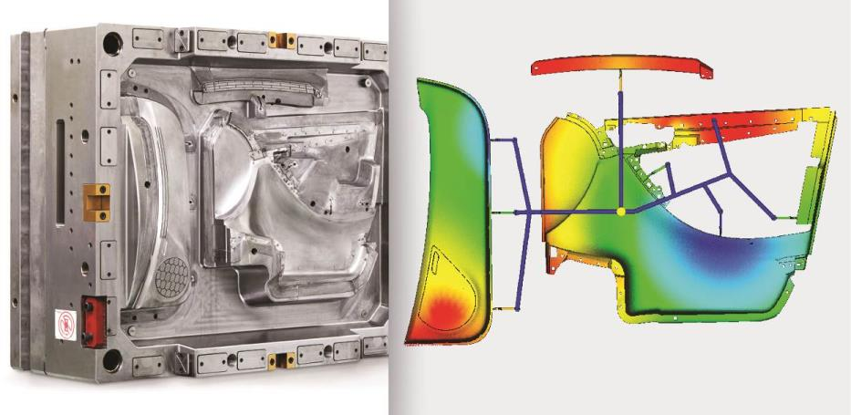
At Fakuma 2018, HRSflow will showcase a new family mold available for customer trials for one-shot production of three very differently sized elements of a car door module. The precise and responsive FLEXflow technology allows for low-warpage, defect-free parts with finely grained surfaces. © HRSflow
San Polo di Piave/Italy and Friedrichshafen, October 16, 2018 – At Fakuma 2018, HRSflow (www.hrsflow.com) showcases a new family mold for one-shot production of three high-quality visible parts for a door module for car interiors. The use of the FLEXflow technology ensures flawless, finely grained surfaces without pressure lines or flow marks even though these parts differ considerably from one another in terms of their dimensions and volumes.
FLEXflow manages the individual control of the servo-electric drives for all the eight hot runner valve gate systems used in this application. This means the position and speed of each individual valve pin can be finely regulated to optimize the appropriate pressures, flow rates and volumes of the melt in all three cavities. This precise control prevents overfeeding and flash formation on smaller parts while all cavities are filled at the same time.
The mold, equipped with hot runner nozzles from HRSflow's middle range, is designed for sequential injection molding. The aligned opening of these nozzles, which is made possible by FLEXflow, alleviates the pressure loss that often occurs during this injection molding process, and thus eliminates the accompanying surface marks. And, thanks to the ability to precisely control the pressure on each nozzle during the holding pressure phase, the exact shrinkage of the desired part can be attained in each individual cavity. In regard to the cross-sections, the overall hot runner system is also designed so material and color changes can be performed quickly.
The mold, which is intended primarily for processing propylene and additionally ABS, will be available to HRSflow customers after the Fakuma show for trials with their own materials. Stephan Berz, Vice President of HRSflow: "Having last year presented a well-balanced hot runner solution for the production of high-quality, chrome-platable radiator grille elements in a single shot, we now also have a corresponding, high-performance solution for the vehicle interior. The control of the mold-filling process using the FLEXflow technology is able to satisfy particularly demanding specifications. The volumes of the three elements in the new demonstrator mold – door liner, map pocket and reinforcing bar – are 560 cm³, 338 cm³ and 58 cm³ respectively, while the average wall thickness varies between 2.3 mm with the largest part and 3 mm with the smallest one. The fine grain of the visible surfaces and the delicate open net structure of the loudspeaker grille integrated into the map pocket are real challenges that we have successfully mastered."
As an alternative to the full FLEXflow technology, operators can also utilize the new mold in combination with the cost-effective and easy-to-manage FLEXflow One product, in which a responsive driver module coupled to each individual nozzle controls the melt flow. The processor transmits the individual data on valve pin position, stroke and velocity to the respective module, which then automatically controls the valve pin motion. If required, this setup also performs well in a multi-stage arrangement.
Berz continued: "Our new family mold for vehicle interior parts is designed for an injection molding machine with a clamping force of 10,000 kN. In order to be able to gain information about the mold-filling process, we have placed two pressure sensors in each of the two larger cavities and one in the small one. In addition, six contact sensors provide information about the mold deflection during the injection phase. This configuration gives our customers the possibility to see for themselves and with their own material the quality and efficiency benefits that this system offers in production. If desired, HRSflow will then provide support with transferring the combination of family mold and FLEXflow technology to the respective customer-specific application."
HRSflow (www.hrsflow.com) is a division of INglass S.p.A. (www.inglass.it), headquartered in San Polo di Piave/Italy. It is specialized in the development and production of advanced and innovative hot runner systems for the injection molding industry. The group of companies has more than 1,100 employees and is present on all the major global markets. HRSflow produces hot runner systems at its European headquarters in San Polo di Piave/Italy, in Asia at its plant in Hangzhou/China and at its facility in Byron Center near Grand Rapids, MI, USA.
Contact and further information
HRSflow, Via Piave 4, 31020 San Polo di Piave (TV), Italy
Phone: +39 0422 750 111, Email: info@hrsflow.com, www.hrsflow.com
Erica Gaggiato, Communication Dept.
Phone: +39 0422 750 120, Email: erica.gaggiato@inglass.it
Editorial contact and voucher copies
Dr.-Ing. Jörg Wolters, Konsens PR GmbH & Co. KG,
Hans-Kudlich-Straße 25, D-64823 Groß-Umstadt, Germany – www.konsens.de
Tel.: +49 (0) 60 78 / 93 63 0, Email: mail@konsens.de
Press releases from HRSflow with text as well as pictures in print-ready resolution are available to download from: www.konsens.de/hrsflow.html

