PRESS RELEASE Contact: Instron European Headquarters
Attn. Sam Heudebourck
Coronation Road, High Wycombe
Buckinghamshire, England, HP12 3SY
Tel: +44 1494 464646
Info_news@instron.com
New Version MPX – the safe and efficient solution for metals impact testing to Charpy and Izod standards
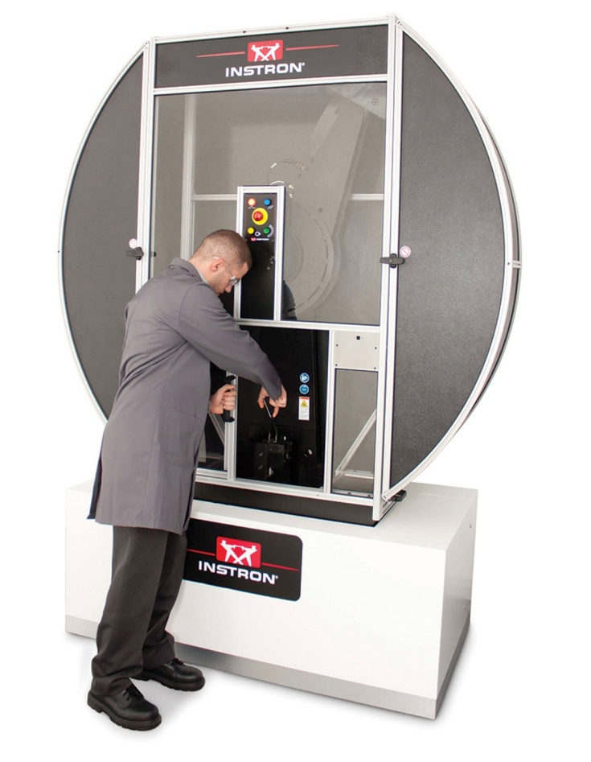
High Wycombe, April 2014 – Instron, a leading provider of testing equipment designed to evaluate mechanical properties of materials and components, offers the MPX Series of motorized pendulum impact testers that are essential for metals impact testing to Charpy and Izod standards.
The MPX Series offers a range of testing capabilities from 300 – 900 Joules and it comes standard with Fracta™ Software, which allows for reliable data acquisition and reporting of absorbed energy. If more advanced impact analysis and reporting is needed, upgrading to Impulse™ Data Acquisition Software and instrumentation will allow for direct measurement of impact force and striker velocity.

Key advantages of the MPX include:
- Automatic Test Start
The MPX is designed with an automatic test start as soon as the door closes, allowing for rapid testing and improving throughput while conforming to the international standards for non-ambient testing. The feature fully complies with NIST 5 second guidelines, specifying the time it should take for the specimen to leave the temperature conditioner and for the test to be complete.
- Interchangeable Hammer Weights
Most other pendulum impact testers on the market still require the hammer assembly to be completely removed in order to change weights. On the MPX, interchangeable hammer weights allow for quick and simple adjustment of the impact energy, removing the need for the time-consuming process of changing hammer shafts.
- Safety
The MPX features an integrated guard and safety control system that meets the stringent requirements for the European CE mark and for ISO 13849. Your operator is protected at all times during machine operation.
Instron (www.instron.com) is a globally leading manufacturer of test equipment for the material and structural testing markets. A global company providing single-source convenience, Instron manufactures and services products used to test the mechanical properties and performance of various materials, components and structures in a wide array of environments. Instron systems evaluate materials ranging from the most fragile filament to advanced high-strength alloys. With the combined experience of CEAST in designing plastic testing systems, Instron enhances materials testing offerings, providing customers with comprehensive solutions for all their research, quality and service-life testing requirements. Additionally, Instron offers a broad range of service capabilities, including assistance with laboratory management, calibration expertise and customer training.
Instron is part of the Test and Measurement division of the US based Illinois Tool Works (ITW) group of companies with more than 850 distributed business units in 52 countries worldwide and a staff of approx. 60,000.
– – – – –

International coordination  Emma Forrest, Instron UK  European Marketing Communications Coordinator  Coronation Road, High Wycombe,  Bucks HP12 3SY, United Kingdom  Phone: +44 (0) 1494 456855, emma_forrest@instron.com | Editorial contact:  Dr.-Ing. Jörg Wolters,  Konsens PR GmbH & Co. KG,  Hans-Kudlich-Straße 25,  D-64823 Groß-Umstadt  www.konsens.de  Tel.: +49 (0) 60 78 / 93 63 - 0, Fax: - 20 mail@konsens.de

Dear editors, please download Instron press releases including text and ready-to-print image file from www.konsens.de/instron.html

