PRESS RELEASE Contact: Instron European Headquarters
Attn. Sam Heudebourck
Coronation Road, High Wycombe
Buckinghamshire, England, HP12 3SY
Phone: +44 (0)1494 464646
Info_news@instron.com
Instron Offers Additional VisualRHEO Packages For Rheological Testing
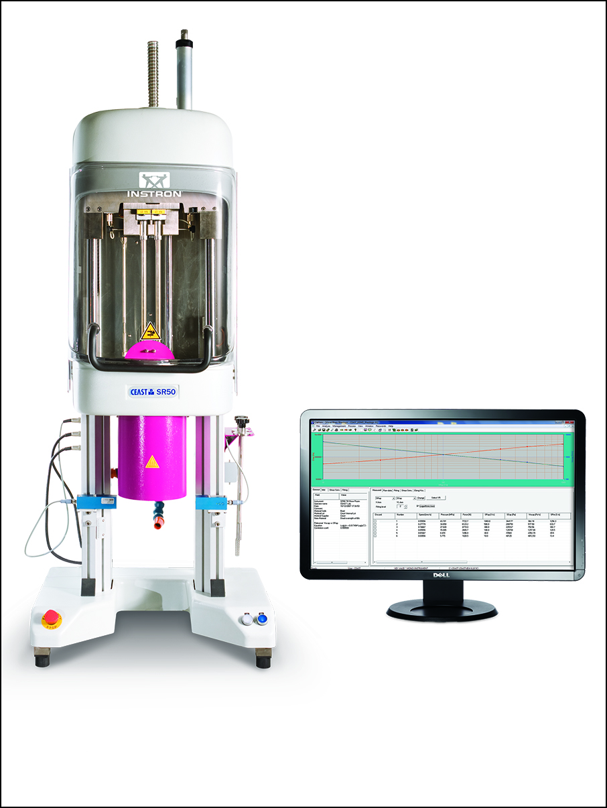
High Wycombe, July 2014 – VisualRHEO is a versatile software package dedicated to managing rheological tests and analysing data and is a fundamental part of Instron® CEAST SmartRheo single- and twin-bore capillary rheometer systems. When combined these products are designed to investigate the flow behavior of plastics over a wide range of shear conditions. Recent extensions are the VisualRHEO Advanced Analysis and the VisualRHEO Advanced Test Management packages, both designed to supply users with additional features in terms of testing procedures and data analysis.
The VisualRHEO software, which manages and analyzes data from rheological tests with steps at constant piston speed or shear rate, enables the technician to have full control over gathering data including viscosity, Bagley and Rabinowitsch corrections, and non-Newtonian index calculations. These results are displayed from both a numerical and a graphical point of view.
VisualRHEO is compatible with Windows® 2000/XP/Vista/7/8.1 and features:
- Real-time graphic display of the measured quantity
- Post-process graphs of rheological quantities (apparent and corrected values)
- Password-protected operator access levels
- Export to spreadsheets, text files, and LIMS systems
- Test comparison and reference viscosity curves
- Advanced database search
Instron’s new VisualRHEO Advanced Analysis Package adds
- Advanced fitting capabilities on rheological curves, using Polynomial, Power Law, Cross and Yasuda-Carreau equations, and showing related coefficients
- Elongational viscosity estimation, using Cogswell method based on Bagley-corrected shear viscosity data
- Wall-slip speed estimation, using Mooney method based on standard tests with different dies (same L/D but different diameters)
- Viscosity Dependence on Temperature analysis, applying Arrhenius and WLF equations to multiple tests at different temperatures to obtain the viscosity-temperature relationship for each shear rate condition
- Performs also the Flow/No-Flow analysis to estimate the limiting temperature condition for flowing
Instron’s new VisualRHEO Advanced Test Management Package adds
- Viscosity dependence on time test mode and analysis. This allows the operator to measure viscosity at different times to study the thermal degradation and other time-depending phenomena. The viscosity results are plotted against time.
- Melt fracture test mode, which allows a shear rate sweep of programmable range and speed, aimed at quickly finding the conditions for unstable flow.
- Stress relaxation test mode, which allows the system to keep measuring the pressure and to calculate viscosity after stopping the piston movement, therefore looking at relaxation phenomena of the sample.

Instron is a leading global manufacturer of testing equipment for the material and structural testing markets used to evaluate materials ranging from native tissue to advanced high-strength alloys. Instron systems perform a variety of tests such as compression, cyclic, fatigue, impact, multi-axis, rheology, tensile, and torsion. Providing single-source convenience through a comprehensive range of solutions and localised service and support, Instron’s broad range of service capabilities include assistance with performance verification and calibration standards compliance, testing system relocation, staff training, and preventative maintenance.
The Instron Centres of Excellence around the world ensure that behind every Instron system is an unprecedented commitment and dedication to quality and customer satisfaction. Instron remains involved with various ASTM and ISO committees, gaining first-hand knowledge of recent and upcoming changes to standards that affect our customers.
– – – – –

International coordination  Emma Forrest, Instron UK  European Marketing Communications Coordinator  Coronation Road, High Wycombe,  Buckinghamshire, England, HP12 3SY  Phone: +44 (0) 1494 456855, emma_forrest@instron.com | Please send voucher copies to:  Dr.-Ing. Jörg Wolters,  Konsens PR GmbH & Co. KG  Hans-Kudlich-Straße 25  D-64823 Groß-Umstadt  www.konsens.de  Tel.: +49 (0) 60 78 / 93 63 - 0, Fax: - 20 mail@konsens.de

Dear editors, please download Instron press releases including text and ready-to-print image file from www.konsens.de/instron.html

