Instron Press Release
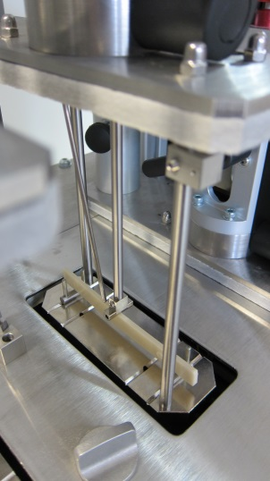
Plast 2015: Instron® Provide Solutions to the Main Challenges in Plastics Testing
Instron, a leading provider of testing equipment designed to evaluate the mechanical and rheological properties of materials, are pleased to announce that they will be exhibiting at Plast 2015. Based at Stand A141 in Hall 11, Instron will be providing the opportunity for visitors to discuss the main challenges that they face when testing plastics, as well as showcasing the range of solutions that can be adopted to avoid these common pitfalls.
Based around extensive primary research conducted by Instron, visitors can learn more about the ways to address the identified main challenges in plastics testing, including; the difficulties in complying with ever evolving testing standards, the main factors that can cause variability of results, and solutions for increasing the efficiency and throughput within their labs.
During the event, Instron will also be giving visitors a unique opportunity to sign up for live demonstrations of new equipment, included as part of a one off masterclass being hosted at Instron’s Centre of Excellence factory in Turin. Attendees to the masterclass will also get to experience a factory tour, and will have the opportunity to learn more first-hand about the best solutions to their plastics testing challenges.
Additionally, visitors to the booth will be able to see some of Instron’s premier equipment for plastics testing, including:
AutoX750 Automatic Contacting Extensometer
Instron’s AutoX750 Automatic Contacting Extensometer, is efficiently designed for the accurate measurement of elongation percentage and the elastic modulus of materials during tensile testing. Meeting the requirements of ISO 527-2, the AutoX750 is used to determine a variety of calculations including modulus, offset yield, and plastic (non-proportional) elongation to failure. It enhances the productivity of testing laboratories with features including automatic gauge length positioning and attachment to the test specimen, resulting in simplified testing routines and improved throughput. Additionally, the use of an automatic extensometer versus a traditional clip-on extensometer can reduce inconsistencies during attachment, greatly improving the repeatability and reproducibility of critical test results.
MF30 Melt Flow Tester
Finally, Instron will also be exhibiting the MF30 Melt Flow Tester, allowing customers the most convenient solution for accurate measurement of the flow properties of plastics according to ASTM D1238 and ISO 1133. Conforming to strict tolerances with regards to temperature accuracy and stability, specimen quantity and pretreatment, the system complies with the stringent requirements of the new testing standard ISO 1133-2 for materials sensitive to time-temperature history and/or moisture.
Visit Instron at Stand A141 in Hall 11 to learn more about the solutions for your plastics testing needs.
About Instron
Instron is a leading global manufacturer of testing equipment for the material and structural testing markets used to evaluate materials ranging from native tissue to advanced high-strength alloys. Instron systems perform a variety of tests such as compression, cyclic, fatigue, impact, melt flow, multi-axis, rheology, tensile, and torsion. Providing single-source convenience through a comprehensive range of solutions and localised service & support, Instron’s broad range of service capabilities include assistance with performance verification & calibration, standards compliance, testing system relocation, staff training, and preventative maintenance.
The Instron Centres of Excellence around the world ensure that behind every Instron system is an unprecedented commitment and dedication to quality and customer satisfaction. Instron remains involved with various ASTM and ISO committees, gaining first-hand knowledge of recent and upcoming changes to standards that affect our customers.
For more information, contact Instron Europe, Coronation Road, High Wycombe, Buckinghamshire, HP12 3SY, United Kingdom Telephone: +44 1494 456815; Email: info_news@instron.com

