Plastic recycling:
Tailor-made plastic washing plant optimizes throughput, product quality and operating cost
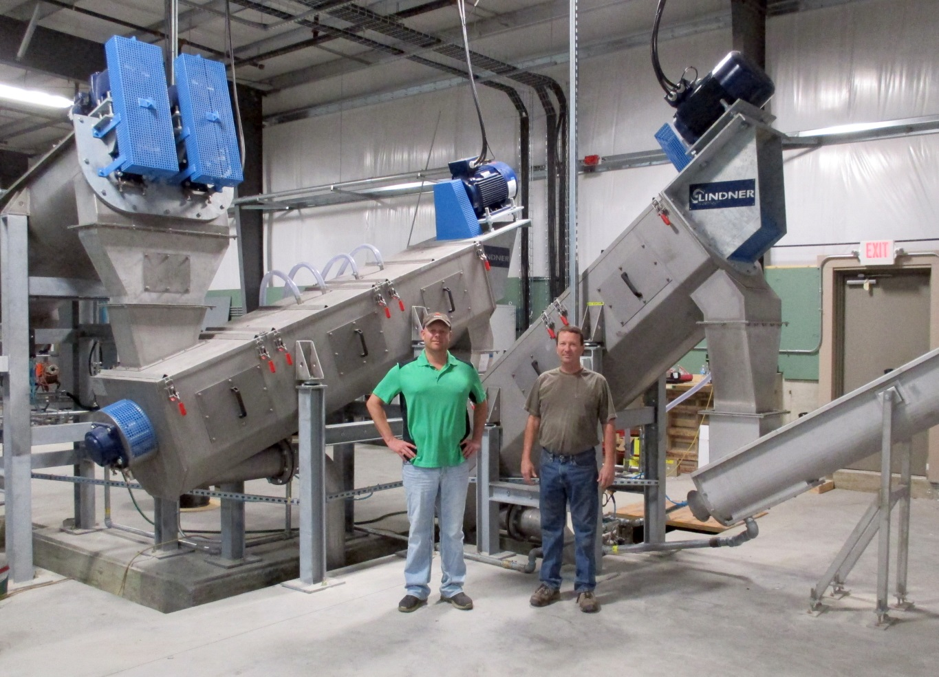
Cedar Poly’s managing directors Scott (left) and Jeremy Rogers (right) have selected Lindner washTech’s modular washing system for their state-of-the-art plastic recycling plant in Tipton, IA/USA
Großbottwar/Germany and Raleigh, NC/USA, January 2015 –– Post-consumer plastic scrap can be made into high-grade recyclates provided that all processing steps are optimally matched. The achievable cost and quality level hinges to a large extent on the efficiency with which the shredded plastic material is washed and dried. The German Lindner washTech GmbH (www.lindner-washtech.com/en/) focuses its activities on just this step in the recycling chain. The company develops and produces washing systems of a customer-focused, application-specific design which deliver an optimized combination of throughput, effectiveness and longevity. Cedar Poly LLC (www.cedarpoly.com) of Tipton/IA, a leading North American plastic scrap trading and recycling company, recently commissioned a plastic washing system from Lindner washTech which enabled them to significantly boost both capacity and product quality.
Lindner Resource America LP will present Lindner washTech’s advanced cleaning technology at NPE, booth S26189.

Cedar Poly uses the new system as part of its recycling line for post-consumer HDPE (high-density polyethylene), which is obtained chiefly in the form of empty containers and bottles. As the company's managing directors Jeremy and Scott Rogers confirm, the plant is now proving its worth in day-to-day operation. "With our old system we had a maximum throughput limit of 300 kg/h, and its cleaning performance was not sufficient to produce a recyclate suitable for direct further processing. After thorough investigation, we opted to purchase the most advanced technology from Europe. In Lindner washTech, we found a partner who possesses an extensive know-how in plastic recycling, prepared to design, build and install a system tailored to our needs."

The custom-designed washing system comprises multiple stages:
- In a first step, the shredded HDPE flakes pass a pre-washing cycle in which the material is soaked and contaminations such as stones, metals and glass are removed.
- Paper label residue and other contaminants are then separated by two washTech LF 600 friction washers (560 mm rotor diameter, 3000 mm rotor length, 30 kW motor). These washing units feature replaceable paddles and screens which help cut the overall operating cost. The newly developed rotor provides highly effective cleaning due to an optimized dwell time of the material.
- Heavier plastic fractions such as PET, ABS or PVC are removed in a further separator stage.
- The material is then sent through a washTech LMD 2000 / 1200 mechanical dryer (1200 mm rotor diameter, 2000 mm rotor length, 90 kW motor) providing a particularly 'gentle' drying action.
- The final stage is an air wash system in which any remaining fines and film particles are separated.

When the cleaned and dried HDPE flakes are subsequently filled into big bags, they have a residual moisture of less than 1 %. Despite this very low moisture level and the high supported throughput rates, the operating costs of this advanced washing system are fairly low because no thermal drying is needed and the water consumption amounts to only around 5 m³/h.

The outstanding ruggedness of the washer system supplied to Cedar Poly is a basic quality which characterizes all recycling equipment and components made by the Lindner Group. Combined with the use of stainless steel for all parts exposed to water, this contributes to the system's high long-time availability and low maintenance needs.

Both managing directors confirm that partnering with Lindner washTech is reaping the benefits now. „With the new system we achieve throughput rates of up to 2500 kg/h, and thanks to its superior cleaning performance we can produce high-grade recyclates in-house. This gives us a clear technological cutting edge over our competitors." As a further benefit which influenced their decision, they point to the Lindner Group's local market presence with two U.S. subsidiaries in Raleigh/SC and Atlanta/GA.

The Lindner Group headquartered at Spittal/Austria was established in 1948 as a mechanical engineering and equipment construction company and has evolved into a competent supplier of shredding technology for industrial applications. Employing around 300 people, the Lindner Group specializes in the development, manufacture and sales of complete lines and machines for producing alternative fuels. Subsidiaries in Raleigh/SC and Atlanta/GA support Lindner’s activities in North America.

Lindner’s sales and customer support company Lindner reSource GmbH, based in Grossbottwar/Germany, represents the Group's plastic and recycling activities. The company supplies high-powered single-shaft shredders with throughputs from 300 to 10,000 kg/h to industrial customers.

As partner to the shredding technology expert Lindner reSource GmbH, Lindner washTech GmbH, also in Großbottwar, supplies complete washing systems as a basis for efficient, high-quality recycling. Their solutions come fully equipped with separator and drier technology, supported by application-specific, optimum matching of all combined systems, and tailored to any requirement or application scale.

Further information:

Harald Hoffmann, Managing Director, LINDNER reSource GmbH
Häldenfeld 4, D-71723 Großbottwar / Germany
Phone: +49 (0) 71 48/16 05 38-0, E-mail: info@lindner-resource.com

Lindner America LP
5126 South Royal Atlanta Drive
Tucker, GA 30084
Contact: Tomas Kepka, Phone: +1 7703496319
E-mail: info@lindner-resource.us, www.lindner-resource.us

Editorial contact and voucher copies:
Dr. Jörg Wolters, Konsens PR GmbH & Co. KG
Hans-Kudlich-Straße 25, D-64823 Groß-Umstadt / Germany
Phone: +49 (0) 60 78/93 63-0, E-mail: joerg.wolters@konsens.de

This press release (.doc file) and the high resolution image(s)
can be downloaded at:
www.konsens.de/lindner-resource.html

