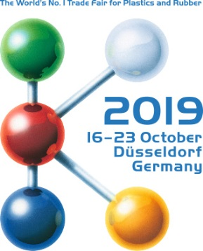  Hall 9 / Booth B22 | Press Release  MTI Mischtechnik International GmbH  Katharina Nowak  Ohmstr. 8, D-32758 Detmold/Germany  Phone: +49 (5231) 914-113  Fax: +49 (5231) 914-299  Email: marketing@mti-mixer.de  Internet: http://www.mti-mixer.de
MTI at K2019
Efficient dehumidification and mixing for the production of natural fiber compounds
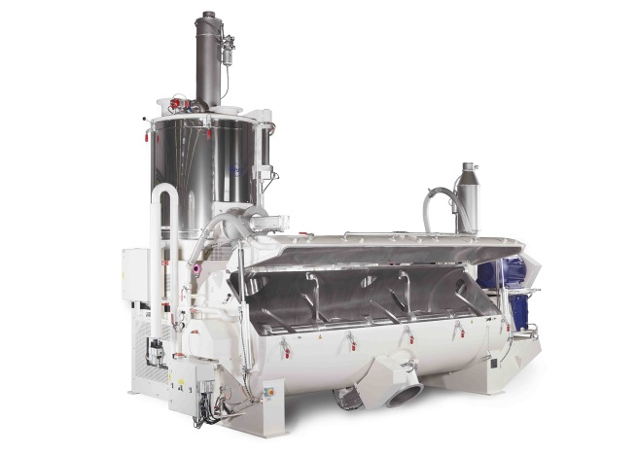
At K2019, MTI Mischtechnik will present a combination of an MTI Flex®-line heating/cooling mixer with a Vent tec® 2.0 aspiration system optimized for the production of natural fiber compounds.
© MTI Mischtechnik
Detmold, Germany, October 2019 – At the K2019 trade show staged in Dusseldorf, Germany from October 16 - 23, 2019, MTI Mischtechnik, a technology and quality leader in the manufacture of mixing and processing machines, will present its current portfolio of container-type, vertical, horizontal, cooling, and heating/cooling mixers for the plastics industry. One highlight at the company's booth B22 in Hall 9 will be an MTI Flex®-line heating/cooling mixer combination, which, together with a Vent tec® 2.0 aspiration system, has been optimized for the production of dry blends for natural fiber compounds (NFC).
Designed as a modular system, the mixers of the MTI Flex®-line series can generally be used for almost any application because the sizes, drives and equipment options can be individually configured. In the M 1000 / K 3300 size shown at K2019, the mixing system comes with a heating mixer volume of 1,101 liters and a cooling mixer volume of 3,308 liters for typical batch sizes of 400 kg and an hourly throughput of over 1,600 kg. It is part of a series of machines that will be delivered to an Asian NFC-processing company after the show.
The performance of the associated Vent tec® 2.0 mixer aspiration system is matched to the intended NFC application. Unlike conventional solutions, these devices control their operation autonomously as a function of actual process parameters, thereby providing constant processing conditions irrespective of changes in process and ambient conditions. They achieve this by continuously monitoring all actual operating conditions via key parameters such as intake air and system air temperatures, air pressure, humidity and, with high significance, the aspiration air flow rate. Their electronic controller continuously analyzes these variables and adjusts the aspiration system accordingly with due regard to filter status, so maintaining constant venting airflow conditions. As a result, even under unfavorable conditions when processing natural fibers with fluctuating but relatively high moisture contents, it ensures highly efficient dehumidification of the blend, thus enabling constant process conditions and consistently high product quality. Thanks to the high drying efficiency, the required preparation times, depending on the raw material moisture content, are usually less than 15 minutes.
In addition to dry blends for natural fiber compounds, the main applications of such mixer-aspiration combinations include the production of almost completely dehumidified rigid and soft PVC dry blends as well as thermal processes where Vent tec® 2.0 devices serve to dehumidify the mixture and/or to reduce volatiles content. Especially with PVC formulations containing hygroscopic stabilizer systems, they reliably prevent the formation of deposits on the interior surfaces of heating mixers, cooling mixer walls and extruder dies, as well as in calibration devices. In this way, they ensure consistent mixing quality while simultaneously preventing extruder problems and fluctuations in the final product.
MTI Mischtechnik International GmbH, established in 1975, is an internationally leading manufacturer of mixing and processing equipment for the plastics processing, chemical, food and pharmaceutical industries. With a staff of more than 50 employees working at its headquarters site in Detmold, Germany, the company manufactures mixer systems noted for their outstanding mixing performance as well as energy and cost efficiency. The portfolio includes vertical high-speed mixers, horizontal mixers, heating/cooling mixer combinations, universal mixers, laboratory mixers, as well as tailor-made systems. With an export rate of around 80%, MTI Mischtechnik is globally aligned and, as an owner-managed family business, relies on quality that is "Made in Germany".
Editorial contact / please send voucher copies to:
Dr.-Ing. Jörg Wolters, KONSENS Public Relations GmbH & Co. KG
Hans-Kudlich-Straße 25, D-64823 Groß-Umstadt / Germany
Phone: +49 (6078) 9363-13, Fax: +49(6078) 9363-20
Email: mail@konsens.de, www.konsens.de
The text of this press release in MS-Word format, as well as the images in
print-quality resolution, are available for download at:
http://www.konsens.de/mti-mischtechnik.html

