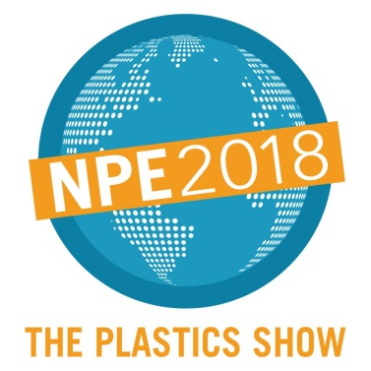  West Hall Level 2, Booth W4545 | Press Release  MTI Mischtechnik International GmbH  Katharina Nowak  Ohmstr. 8, D-32758 Detmold/Germany  Phone: +49 (5231) 914-113  Fax: +49 (5231) 914-299  E-mail: marketing@mti-mixer.de  Internet: http://www.mti-mixer.de
MTI at NPE 2018
Precision mixing in large dimensions
Biggest-ever MTI mixer supplied to the U.S. is exhibited at trade fair booth
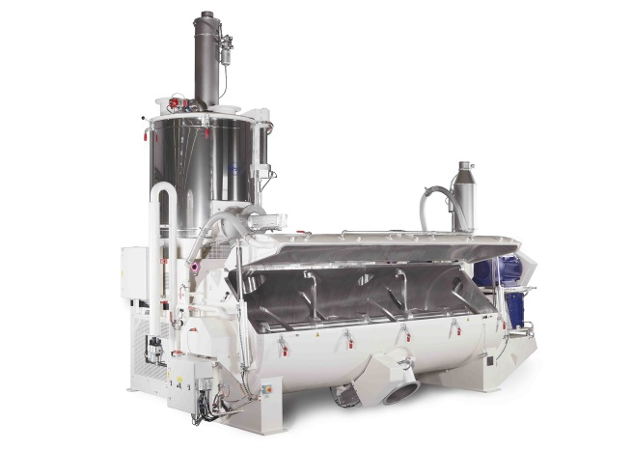 | 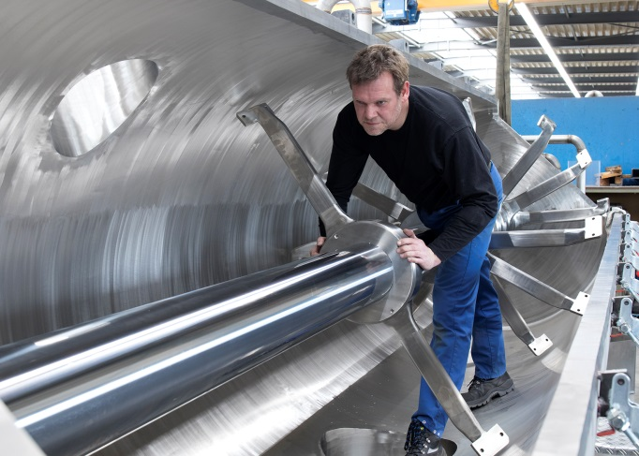
At NPE 2018, MTI Mischtechnik exhibits a Heating/Cooling Mixer Combination MTI Flex®-line that impresses with its outstanding dimensions. The type M 2000 / K 8000 unit features an 8,000 liter cooling vessel while measuring over 7 m (23 ft) in length and close to 5 m (app. 16.5 ft) in height. © MTI Mischtechnik | Still under construction, soon at NPE: The 8,000 liter cooling vessel for Northern Pipe‘s new MTI Flex®-line Heating/Cooling Mixer Combination.  © MTI Mischtechnik
Detmold/Germany, March 2018 – At the NPE 2018 trade show staged in Orlando, Florida from May 7 -11, 2018, MTI Mischtechnik, a technology and quality leader in the manufacture of mixing and processing machines, will present its current portfolio of container-type, vertical, horizontal, cooling, and heating/cooling mixers for the plastics industry. One highlight at the company's booth – #W4545 in the West Hall, Level 2 – is a Heating/Cooling Mixer Combination MTI Flex®-line type M 2000 / K 8000 that impresses with its outstanding dimensions, providing 8,000 liters of cooling vessel capacity while measuring over 7 m (23 ft) in length and close to 5 m (16.5 ft) in height. Directly after the show, the machine is to be shipped to Northern Pipe Products Inc., a major manufacturer of PVC pipe serving the Midwestern USA and Canada. With the installation of this system – the largest heating/cooling mixer combination MTI has ever supplied to the USA – mixing capacity will almost double at this customer's site.
Burkhard Wulf, Area Sales Manager at MTI, comments: „We have been witnessing a trend towards ever-increasing production volumes in the U.S. market for quite some time. With this Flex®-line M 2000 / K 8000 for Northern Pipe Products we address the associated demand; needless to say, the same holds true for our Flex®-line M 2500 / K 8000 model which provides the ultimate in mixer capacity. These systems can deliver the specified mixtures in appropriate quantities without compromising on mixing quality or high-precision recipe compliance. We are looking forward to delivering this large-size machine to Northern Pipe soon – a company which, like our own, has been a hallmark of precision, accuracy and high-grade products for decades.“
„In our production we have relied on an MTI heating/cooling mixer combination with 1,500 liters of heating mixer and 4,250 liters of cooling mixer capacity for almost 30 years now", explains Derek Hanson, Vice President of Engineering at Northern Pipe. "In 2014, acting in close cooperation with MTI, we replaced the original cooler with a revised model of the same type. Unfortunately, it was not possible to install a larger system at the time as we had utilized the available floor space optimally already. The entire machine has been performing with high reliability since its installation, and when we needed spare parts they were promptly made available to us, along with the associated customer service. Still, the day came where this system's output could no longer keep up with our demand. Once we resolved to install a significantly larger unit, it was only logical that we should go back to MTI for its implementation. Together, we managed a solution despite all the prevailing space constraints. MTI modified the machine's design, building it around the existing steelwork, as it were. We are now eagerly awaiting its delivery and commissioning since this will overcome a real bottleneck in our plans to expand production capacity.“
The M 2000 / K 8000 is an MTI heating/cooling mixer combination rated for a typical batch volume of 950 kg (app. 2,100 lbs). It can thus provide more than 7,500 kg (app. 16,600 lbs) of mixed material per hour. Like all MTI Flex®-line mixers, the machine meets highest standards of mixing quality even with exacting mixing tasks. Designed on a modular principle, these mixers can be put to use in virtually any application because their sizes, drive units and equipment options can be individually configured.
Christian Honemeyer, Managing Director at MTI, adds: „It is our declared strategy to resolve even the most challenging mixing tasks jointly with our customers, including custom developments to address highly specific boundary conditions. It is on the basis of this approach that, over the last few years, we have been building our current strong market position as a globally leading provider of mixing equipment. This also applies to the booming U.S. market, where over 100 MTI systems are now in operation. The M 2000 / K 8000 unit specially adapted to Northern Pipe's plant layout situation quite clearly reflects our self-concept as a flexible, customer focused innovator in the mixer industry. In fact, the application range of our machines extends from volume manufacturing to the development laboratory, where they support effortless upscaling. We thus cover all typical requirements for batch mixing processes.“
Northern Pipe Products, located in Fargo, North Dakota/USA, supplies PVC pipe to the municipal water, rural water, wastewater, well casing, plumbing and irrigation markets throughout the Midwestern United States and Canada. Since 1979, Northern Pipe Products has focused on manufacturing the highest quality PVC pipe while providing a level of service second to none. All products are manufactured and tested to the applicable standards and specifications defined by the American Water Works Association (AWWA) and/or ASTM International (American Society for Testing and Materials). In addition to Northern Pipe’s vigorous internal quality assurance procedures, Northern Pipe Products is listed by nationally recognized third-party testing agencies. These agencies routinely inspect the Northern Pipe Products plant and test finished pipe.
Northern Pipe Products is a Varistar Company and a wholly owned subsidiary of Otter Tail Corporation. Otter Tail Corporation (OTTR) is publicly traded on the NASDAQ.
MTI Mischtechnik International GmbH, established in 1975, is an internationally leading manufacturer of mixing and processing equipment for the plastics processing, chemical, food and pharmaceutical industries. With a staff of more than 50 employees working at its headquarters site in Detmold, Germany, the company manufactures mixer systems noted for their outstanding mixing performance as well as energy and cost efficiency. The portfolio includes vertical high-speed mixers, horizontal mixers, heating/cooling mixer combinations, universal mixers, laboratory mixers, as well as tailor-made systems. With an export rate of around 80%, MTI Mischtechnik is globally aligned and, as an owner-managed family business, relies on quality that is "Made in Germany".
Editorial contact / please send voucher copies to:
Dr.-Ing. Jörg Wolters, KONSENS Public Relations GmbH & Co. KG
Hans-Kudlich-Straße 25, D-64823 Groß-Umstadt / Germany
Phone: +49 (6078) 9363-13, Fax: +49(6078) 9363-20
E-mail: mail@konsens.de, www.konsens.de
The text of this press release in MS-Word format, as well as the images in
print-quality resolution, are available for download at:
http://www.konsens.de/mti-mischtechnik.html

