Recycled Mafill® PP now available in identical quality worldwide
Geiger Automotive opts to use it in European and US manufacturing operations
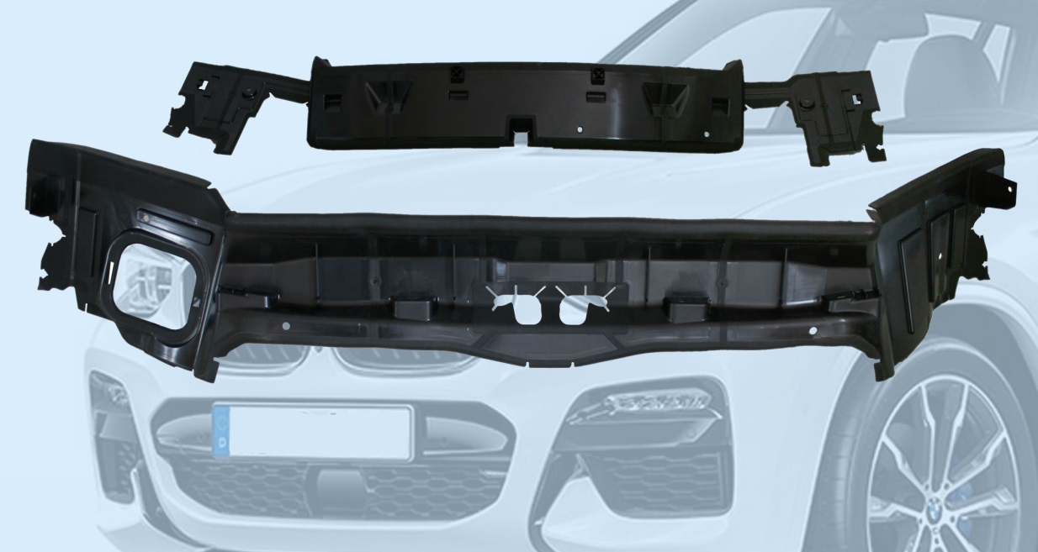
Geiger Automotive is using Ravago's recycled PP grade Mafill® CR HT 5344 H, produced in matching quality in Europe and the USA, for producing thin-walled parts for the air guide that directs cooling air to the BMW X3 engines.
Zwingenberg/Germany, February 2019 -- Mafill® CR HT 5344 H is Ravago's first globally available recycled polypropylene grade to meet the same specifications – irrespective of whether it is produced from the starting materials regionally available in Europe or the USA. This was a key factor in the decision by Geiger Automotive, a leading international tier 1 automotive industry supplier, to use this material to manufacture the air inlet which supplies fresh air to the engine radiators in the BMW X3. Geiger produces the parts, which are about 600 mm by 300 mm in size and have wall thicknesses of between 1.2 mm and 2.0 mm, at its Suwanee plant in Georgia, USA. The expertise and intercontinental contacts of the distributor Resinex Germany made a substantial contribution to making this success a reality.
From the outset of the project, a need for cost efficiencies and the automotive industry's efforts to behave sustainably were both factors in favor of using a recycled material. Ravago's existing talcum-filled, heat-stabilized Mafill® CR HT 5344 H grade fitted the bill perfectly. As Linus Winkler, Director Supply Chain Management at Geiger, says: "For some years now, RESINEX has been supplying its European-manufactured recompound to our plant in Germany for various applications. So our experience in terms of processing and service characteristics has been entirely positive." Because the Ravago Group also compounds this Mafill® grade in its subsidiary Ravago Manufacturing Americas, RESINEX recommended that Geiger also make use of it in its manufacturing operations in the USA.
Winkler explains, "In-house testing has demonstrated that batches from both Europe and overseas are completely identical in quality. Changing over on the fly from the European to the US material required no changes to machine parameters. Indeed, the low distortion and dimensional stability of the molded parts were at the same high level. These results were the basis for our decision also to use this recompound for our US manufacturing operations."
Mafill® CR HT 5344 H, one of Ravago's comprehensive range of recycled PP grades, is suitable for demanding technical applications, combining very good mechanical properties with a favorable price. The product range includes unfilled natural colored, black, terracotta and green grades, compounds filled with talcum or CaCO₃ and/or reinforced with glass fibers, together with elastomer-modified, UV- and heat-stabilized and custom products covering a MFI range from 1.5 to 40 g/10 min. Typical automotive applications include wheel arch liners, air filter housings, front-end mountings, air ducts and containers.
About RESINEX
RESINEX (www.resinex.com), a distributor operating under the umbrella of the international Ravago Group, is a European market leader. More than thirty branches and local warehouses serve the whole of Europe and Turkey. Its products include virtually the entire range of engineering thermoplastics, standard polymers, thermoplastic elastomers, natural and synthetic rubbers, recycled materials, functional additives and color concentrates (masterbatches). RESINEX also has the expertise to offer processors individual advice on any development and manufacturing issues.
Editorial queries to:
RESINEX Germany GmbH, Gernsheimer Str. 1, 64673 Zwingenberg
Michael Fischer, michael.fischer@resinex.de
Tel.: +49 (0) 6251 7707-147, Fax: -347, Cellular: +49 (0) 171 9733269
Please send voucher copies and references to online publications to:
Konsens PR GmbH & Co. KG, Hans-Kudlich-Straße 25, 64823 Groß-Umstadt
Dr.-Ing. Jörg Wolters, mail@konsens.de
Tel.: +49 (0) 6078 93630
This press release as a Word file together with the photo in print-ready resolution can be downloaded from: http://www.konsens.de/resinex.html

