Tosaf’s new MT7636PE delivers matte effect on polyolefin films without additional converting process
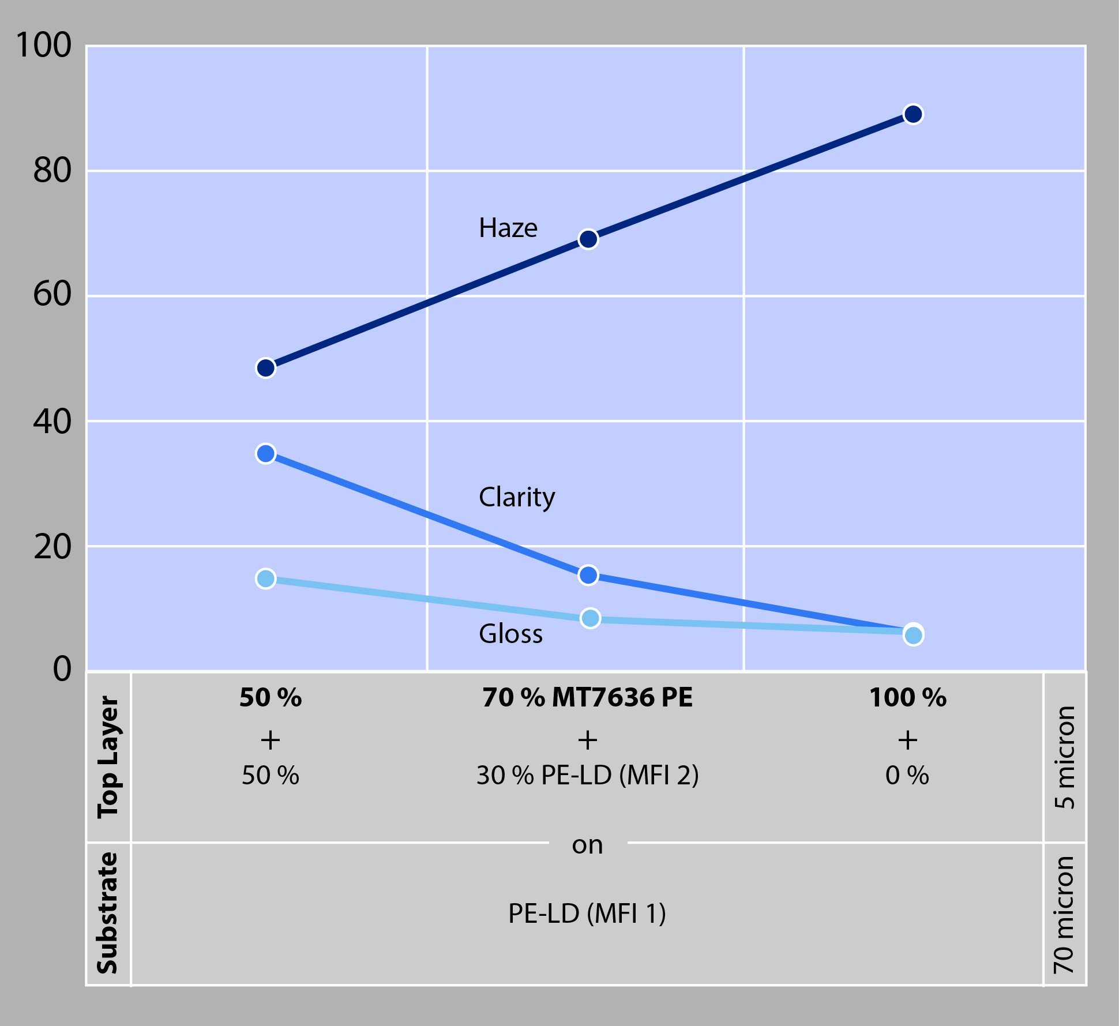
Addition of Tosaf’s new MT7636PE to an ultra-thin PE top layer significantly changes the visual appearance of a PE-LD film in terms of haze, clarity and gloss
Alon Tavor, Israel, September 2018 –– MT7636PE is a newly developed matte additive from Tosaf to create thin (2 to 5 microns) skin layers on oriented and non-oriented polyolefin films, now including Polyethylene, combining superb haze (app. 80 %) with extremely low gloss (<10). Specific areas with matte effect can be made transparent by applying a lacquer coating or by gluing a clear label on top of the matte layer.
Based on a special polymer mixture which does not contain fillers, MT7636PE provides outstanding advantages including:
• full control of haze/gloss properties on demand
• cost saving matte effect without additional converting process
• excellent rheology for easy processing
• low die build-up
• suitable for PE and PP films
Using MT7636PE, converters can easily achieve a luxurious look thanks to a uniformly continuous light transmission with a perfectly consistent transparency level over the entire surface. Beyond, this new matte additive provides a perfect substrate to be printed with a clear lacquer, thus providing areas with complete transparency. Thanks to its high surface roughness, MT7636PE supports good adhesion of such lacquers and other inks to the film.
Typical applications of MT7636PE include food packaging, mainly dry food such as pasta, bread, etc. as well as pet food.
About Tosaf:
For over three decades, Tosaf has been developing and manufacturing high quality additives, compounds and color masterbatches for the plastics industry. With the aim of providing for its customers’ every need, it has continuously grown and developed its offering, production capacity, and global reach, becoming a truly close to the market, global organization.
Servicing customers in over 50 countries in Europe, North America, South America, Asia and the Middle East, Tosaf has over 1000 employees spread throughout its production sites, warehouses, sales and distribution offices around the world.
Tosaf CEO Amos Megides established the company in Israel in 1986, and still stands at its head, leading and inspiring his team to always uphold the following three pillars: Exceptional service, the highest quality and continuous innovation.
Tosaf’s major shareholders include: Megides Holdings Ltd. and the Ravago Group.
For further information about Tosaf please contact:
Ms. Ronit Segal Hayoon
Global Marketing Communication Manager
Tosaf Compounds Ltd.
Phone: +972 9 8984790
Email: ronith@tosaf.com
Editorial contact, and please send voucher copies to:
Dr.-Ing. Jörg Wolters
KONSENS PR GmbH & Co. KG
Hans-Kudlich-Str. 25, D-64823 Groß-Umstadt,
Phone: +49 6078 9363-13
Email: mail@konsens.de

