Press RELEASE

New cooling masterbatch for greenhouse films cuts down peak interior temperature in hot regions

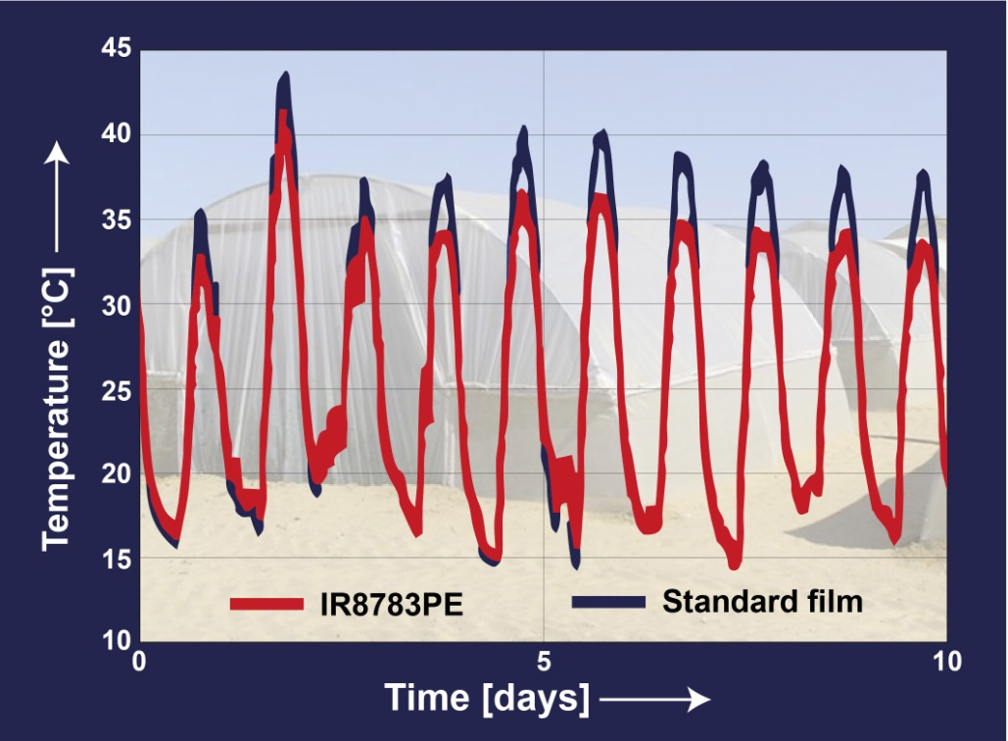
In field tests in South Israel, greenhouse films produced with Tosaf’s new cooling masterbatch IR8783PE reduced the peak temperature inside a greenhouse tunnel by up to 5°C in comparison with a conventional film containing a light diffuser.

Afula/Israel, August 2014. IR8783PE is a new cooling masterbatch from Tosaf (www.tosaf.com) for greenhouse film applications. Designed to support optimal plant growth in hot climate zones, films produced with IR8783PE block a significant amount of the near infrared radiation (NIR), which would otherwise heat up the greenhouse interior particularly strongly. Most of the photosynthetically active radiation (PAR), which is required for a healthy plant growth, can pass through the films unhindered. Field trials in South Israel revealed a 4 to 5°C lower peak temperature in comparison with conventional light diffusing film with no undesired overnight temperature drop. With a recommended rate of addition of approx. 5% for a 200 micron film, the new masterbatch is suitable for single, three and five layer films.

Cultivating crops in very hot regions, such as the subtropics or Southern Europe, is made difficult by the plants' ability to produce pollen being reduced at high temperatures. The most common remedy, namely painting the films with whitewash, not only entails additional labor but at the same time cuts out some of the essential PAR. Films produced with IR8783PE can not only save this extra labor but also lower the temperature without significant PAR loss.

Tosaf Group, founded in 1985, is a joint-venture between Megides Holding and the Ravago Group. The group operates nine factories in Israel, Turkey, Germany, UK, The Netherlands and the Ukraine, with a total of 800 employees. Tosaf’s versatile range of products includes mineral-filled compounds for the white goods industry, automotive and other plastic industries; additives such as UV-/light stabilizers, flame retardants and customized additives for applications including BOPP, agricultural, packaging and industrial films, polycarbonate sheets, pipes, foams and other products; and color masterbatches for a wide range of applications.

Dear editor:
- For further information on Tosaf please contact
Mrs. Keren Leffler
International Marketing
Tosaf Compounds Ltd.
Telefon: +972-9-8789-703
Fax: +972-9-8789-723
E-Mail: kerenl@tosaf.com
- Editorial contact, and please send voucher copies to:
KONSENS PR GmbH & Co. KG
Dr. Jörg Wolters
Hans-Kudlich-Str. 25
D-64823 Groß-Umstadt,
Phone: +49 (0) 60 78/93 63-13
Fax: +49 (0) 60 78/93 63-20
E-mail: mail@konsens.de

Dear editors,
for your convenience please download image and text of this press release from: http://www.konsens.de/tosaf.html

