Booth D22, Hall 01 | PRESS RELEASE

Digital platform and meeting place for the plastic manufacturing industry
Mobile ap “m-hub” is here!
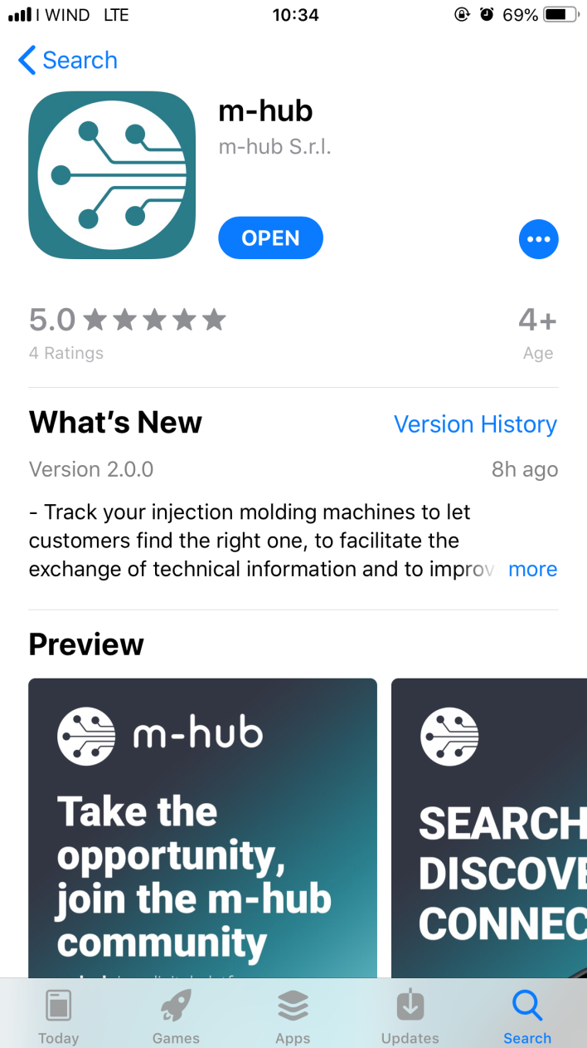
Treviso (TV), Italy, October 2019 –
m-hub S.r.l. (www.m-hub.com) is glad to announce the official launch of the m-hub mobile ap at K show (Hall 01//D22), the new digital platform for the plastic manufacturing industry, meeting point of a worldwide community for the exchange of knowledge and thus strengthening a company's success, worldwide.
Born from the needs experienced through the years by people working in this field, m-hub is a mobile application aiming to break down any barrier between players and within the single organization, facilitating the retrieval of business and technical information.
The m-hub platform aims to create the biggest worldwide network in the plastic manufacturing supply chain and to become the reference place for business and technical data management.
m-hub will provide access to an innovative showcase of companies, technologies and services, offering visibility to all players in the plastic industry. Moreover, users will be able to digitalize the specification of injection molding machines and to perform advanced searches of companies and machines according to powerful filters.
m-hub is available in Google PlayStore, Apple AppStore and soon also in the Chinese Android Stores (Tencent and others), initially in English, German and Chinese. Other languages will be added soon.
For any further information, visit m-hub booth D22, Hall 01.
About m-hub
m-hub (www.m-hub.com) is the ultimate community for meeting new partners and engaging with any stakeholder of the manufacturing industry linked to the plastic supply chain.
No matter if you are a Molder or a Materials Supplier, a Toolmaker or a Components Supplier, an Equipment Manufacturer or a Service Provider…
If you are a player with direct and indirect interests in the plastic industry, m-hub is for you.
Contact and further information:
M-HUB SRL
Via Castelmenardo 55
31100 - Treviso (TV), Italy
Email: info@m-hub.com , www.m-hub.com
m-hub Project Manager: Andrea Tellan
Phone: +39 +393426002408, Email: andrea.tellan@m-hub.com
Editorial Contact and please send voucher copies to:
Dr.-Ing. Jörg Wolters, Konsens PR GmbH & Co. KG,
Hans-Kudlich-Straße 25, 64823 Groß-Umstadt, Germany – www.konsens.de
Tel.: +49 (0) 60 78 / 93 63 - 0, E-Mail: joerg.wolters@konsens.de
Press releases from m-hub with text and pictures in printable resolution can be downloaded at www.konsens.de/m-hub.html

